Event 2006.12.14 – (2006-348)

Particle event: To(Ep>10MeV) – 14d23^{h}
Tmax(Ep>10MeV) – 15d00^{h}, Jmax (Ep>10MeV) – 160 /cm².s.sr
Duration of the event – 3 days
Energy of the SCR and 0.1 GCR fluxes balance – Eb ≥ 500 MeV

Sun source: ● solar flare 14d21^{h}07^{m}, X1.5/2B, S06W46, АR10930
Main X-ray burst 1-8 Ǻ: onset – 14d21^{h}07^{m}, max – 14d22^{h}15^{m}, Ф = 0.12 J/m²
CME: 14d22^{h}30^{m}, V = 1042 km/s, Δφ = 360º, dA = 248º;
▲SC 16d17^{h}55^{m};

Particle fluxes and associated phenomena
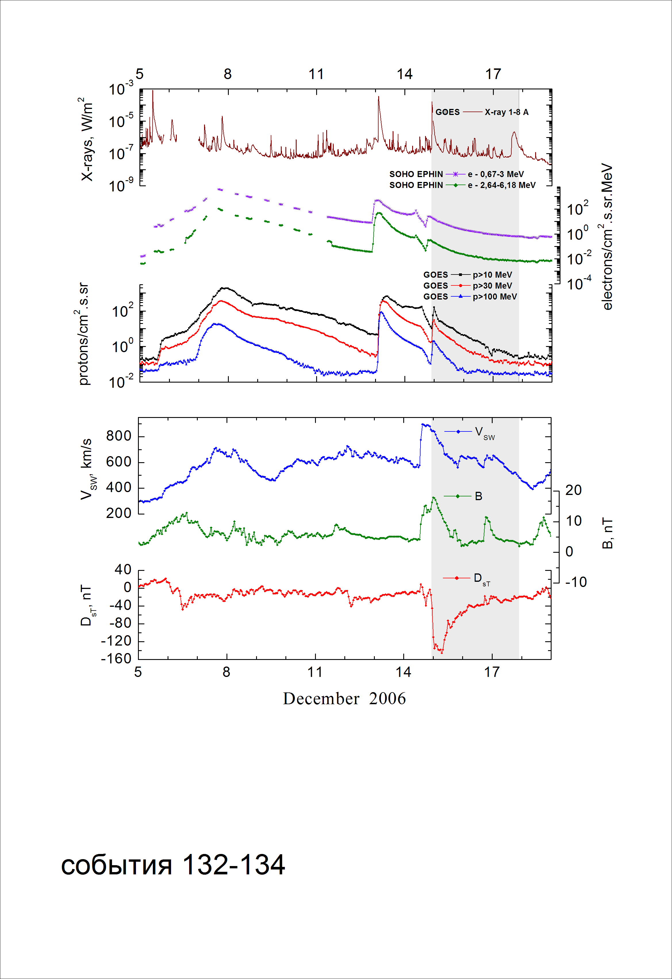
Integral time-of-maximum proton spectrum
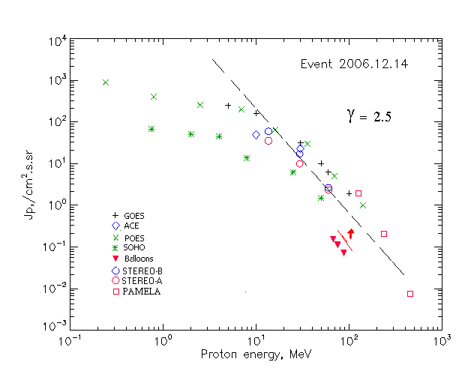

Integral fluxes of protons for the event of 2006.12.14

S/c, instruments | Eр, MeV | To | Tmax | Jmax,  (cm².s.sr)⁻¹ | Dura-tion | Comments
GOES-10
EPS | >5 | 23^{h} | 15d00^{h} | 245 | 3d
EPS | >10 | 23^{h} | 15d00^{h} | 160 | 3d
EPS | >30 | 23^{h} | 15d00^{h} | 31 | 2d
EPS | >50 | 22^{h} | 15d00^{h} | 10 | 2d
EPS | >60 | 22^{h} | 23^{h} | 6.2 | 1d
EPS | >100 | 22^{h} | 23^{h} | 1.9 | 1d
POES-16
MEPED | >0.24 | - | 15d02^{h} | 920 | 3d
MEPED | >0.8 | - | 15d02^{h} | 410 | 3d
MEPED | >2.5 | - | 15d01^{h} | 250 | 3d
MEPED | >6.9 | - | 15d01^{h} | 230 | 3d
MEPED | >16 | - | 15d01^{h} | 65 | 2d
MEPED | >36 | - | 15d01^{h} | 31 | 2d
MEPED | >70 | - | 15d00^{h} | 5 | 1d
MEPED | >140 | - | 15d00^{h} | 1 | 1d
ACE
SIS | >10 | 23^{h} | 15d01^{h} | 49 | 2d
SIS | >30 | 22^{h} | 15d01^{h} | 23 | 1d
SOHO
EPHIN (INT) | >50 | 22^{h} | 15d01^{h} | 1.5 | 1d
BALLOONS
Mi | >68 | - | 16d11^{h}39^{m} | 0.15 | - | After maximum
Mi | >75 | - | 16d11^{h}39^{m} | 0.11 | - | - “ -
Mi | >88 | - | 16d11^{h}39^{m} | 0.07 | - | - “ -

Differential fluxes of protons for the event of 2006.12.14

S/c, instruments | ∆Е, MeV | To | Tmax | Jmax, (cm².s.sr.MeV)⁻¹ | Dura-tion | Comments
SOHO
LION | 0.75-2 | 15d01^{h} | 15d02 ^{h} | 13.2 | 3d
LION | 2-6 | 15d01^{h} | 15d02 ^{h} | 1.9 | 3d
EPHIN | 4-8 | 15d00^{h} | 15d01 ^{h} | 7.8 | 3d
EPHIN | 8-25 | 15d00^{h} | 15d01 ^{h} | 0.43 | 3d
EPHIN | 25-41 | 23^{h} | 15d01 ^{h} | 0.17 | 3d
STEREO - A
HET | 13.6-29.5 | 23 ^{h} | 15d00^{h} | 1.6 | 8d
HET | 29.5-60 | 23 ^{h} | 15d00^{h} | 0.3 | 8d
HET | 60-100 | 23 ^{h} | 15d00^{h} | 0.016 | 8d
STEREO - B
HET | 13.6-29.5 | 23 ^{h} | 15d00^{h} | 3.1 | 8d
HET | 29.5-60 | 23 ^{h} | 15d00^{h} | 0.54 | 8d
HET | 60-100 | 23 ^{h} | 15d00^{h} | 0.023 | 8d
PAMELA
Tracker | 126-136 | 23 ^{h} | 23 ^{h}30^{m} | 0.03 | <1d
Tracker | 237-265 | 23 ^{h} | 23 ^{h}30^{m} | 0.0017 | <1d
Tracker | 455-512 | 23 ^{h} | 23 ^{h}30^{m} | 0.00013 | <1d

References:
Adriani O., Barbarino G.C., Bazilevskaya G.A. et al., 2011.
Mulligan T., Blake J.B., Mewaldt R.A., 2008.
T.T. von Rosenvinge, Richardson I.G., Reames D.V., 2009.
De Simone N., Adriani O., Barbarino G.C. et al., 2009.
Веселовский И.С., Мягкова И.Н., Яковчук О.С., 2012.

