Event 1997.11.13 – (1997-317)

Particle event: To(Ep>10 MeV) – 13d23^{h}
Tmax(Ep>10 MeV) – 14d04^{h}, Jmax (Ep>10 MeV) – 1.3 /cm².s.sr
Duration of the event – 2 days
Energy of the SCR and 0.1 GCR fluxes balance – Eb = 170 MeV

Sources: □ flare event on the back side, AR8100 5d behind W-limb
CME: 13d22^{h}26^{m}, V = 546 km/s, Δφ = 288º; dA = 310º

Particle fluxes and associated phenomena
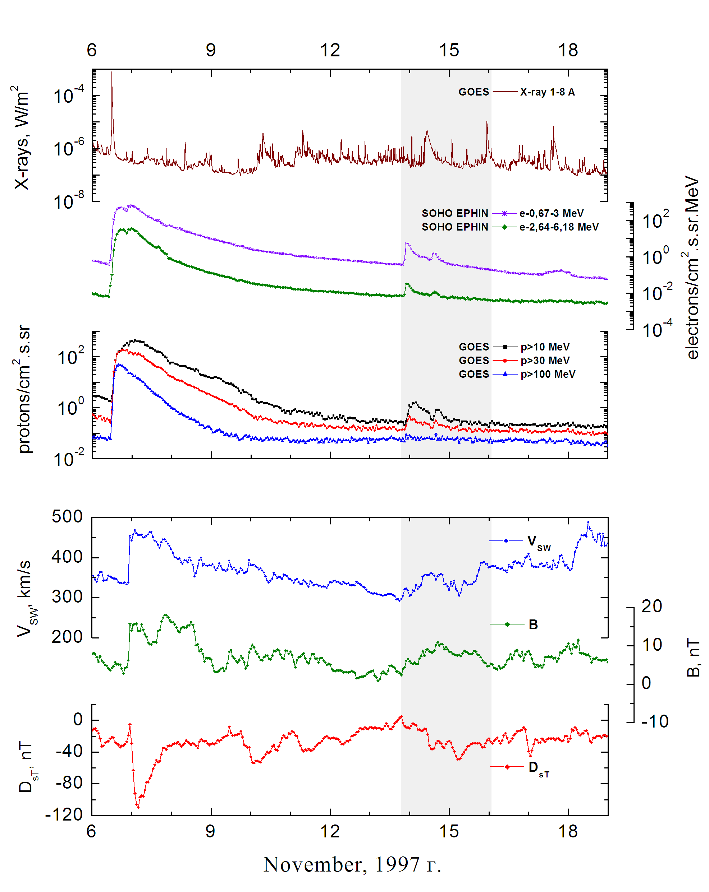
Integral time-of-maximum proton spectrum
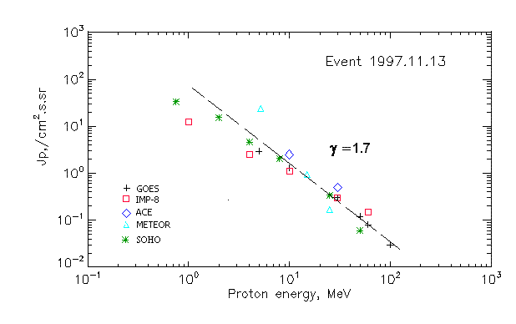

Integral fluxes of protons for the event of 1997 November 13

S/c, instruments | Eр, MeV | To | Tmax | Jmax,  /cm².s.sr | Dura-tion | Comments
GOES-9
EPS | >5 | 23^{h} | 14d04^{h} | 2.9 | 2d
EPS | >10 | 23^{h} | 14d04^{h} | 1.3 | 2d
EPS | >30 | 23^{h} | 14d00^{h} | 0.3 | 2d
EPS | >50 | 23^{h} | 14d00^{h} | 0.12 | 2d
EPS | >60 | - | 14d00^{h} | 0.08 | 2d
EPS | >100 | - | 22^{h} | 0.03 | 2d
METEOR-2
CBM | >5 | 21^{h} | 22^{h} | 23,7 | 2d
CBM | >15 | 22^{h} | 14d00^{h} | 0.95 | 1d
CBM | >25 | 22^{h} | 14d00^{h} | 0.17 | 1d
CBM | >40 | - | - | - | -
BP | >90 | - | - | - | -
ChD | >600 | - | - | - | -
IMP-8
CPME | >1 | 23^{h} | 14d06^{h} | 12.5 | 2d
CPME | >4 | 23^{h} | 14d03^{h} | 2.5 | 2d
CPME | >10 | 23^{h} | 14d02^{h} | 1.1 | 2d
CPME | >30 | 23^{h} | 14d01^{h} | 0.3 | 2d
CPME | >60 | 22^{h} | 14d00^{h} | 0.15 | 2d
ACE
SIS | >10 | 21^{h} | 14d02^{h} | 2.5 | 2d
SIS | >30 | 22^{h} | 14d00^{h} | 0.5 | 2d
SOHO
EPHIN (INT) | >50 | 23 ^{h} | 14d00^{h} | 0.06 | -

Differential fluxes of protons for the event of 1997 November 13

S/c, instrument | ∆Е, MeV | To | Tmax | Jmax.  /cm².s.sr.MeV | Dura-tion | Comments
IMP-8
CPME | 1-2 | 23^{h} | 14d11^{h} | 8 | ∼3d
CPME | 2-4.6 | 23^{h} | 14d06^{h} | 2.2 | ∼3d
CPME | 4.6-15 | 21 ^{h} | 14d02^{h} | 1.8 | ∼3d
CPME | 15-25 | 22 ^{h} | 14d01^{h} | 0.05 | ∼3d
CPME | 25-48 | 18 ^{h} | 14d01^{h} | 0.01 | ∼3d
CPME | 48-96 | 22 ^{h} | 23^{h} | 0.004 | ∼3d
CPME | 96-145 | 20 ^{h} | 14d01^{h} | 0.003 | ∼3d
CPME | 145-440 | 21 ^{h} | 23^{h} | 0.002 | ∼3d
SOHO
LION | 0.75-2 | 14d01^{h} | 14d06^{h} | 11 | ∼3d | 1.1
LION | 2-6 | 23^{h} | 14d05^{h} | 2.5 | ∼3d | 0.2
EPHIN | 4-8 | 23^{h} | 14d06 ^{h} | 0.6 | ∼3.5d | <<
EPHIN | 8-25 | 23^{h} | 14d01^{h} | 0.1 | ∼3.5d | <<
EPHIN | 25-41 | 23^{h} | 14d00^{h} | 0.01 | ∼3.5d | <<
EPHIN | 41-53 | - “- | - “ - | - “ - | - “ - | - “ -

References
Lario D., R.G. Marsden, T.R. Sanderson, et.al., 1998.
Krucker S. and R.P. Lin. 2000.

