Event 1998.05.02 – (1998-122)

Particle event: To(Ep>10 MeV) – 02d14^{h}
Tmax(Ep>10 MeV) – 02d16^{h}, Jmax (Ep>10 MeV) – 130 /cm².s.sr
Duration of the event – 3 days
Energy of the SCR and 0.1 GCR fluxes balance – Eb = 800 MeV

Sources: ● solar flare 02d13^{h}31^{m}, X1.1/3B, S15W15, АR8210
Main burst X-ray 1-8 Ǻ: onset – 02d13^{h}31^{m}, max – 02d13^{h}42^{m}, Ф = 0.067 J/m²
CME: 02d14^{h}06^{m}, V = 0938 km/s, Δφ = 360º, dA = 331º
ΔSC 03d17^{h}43^{m}

Particle fluxes and associated phenomena
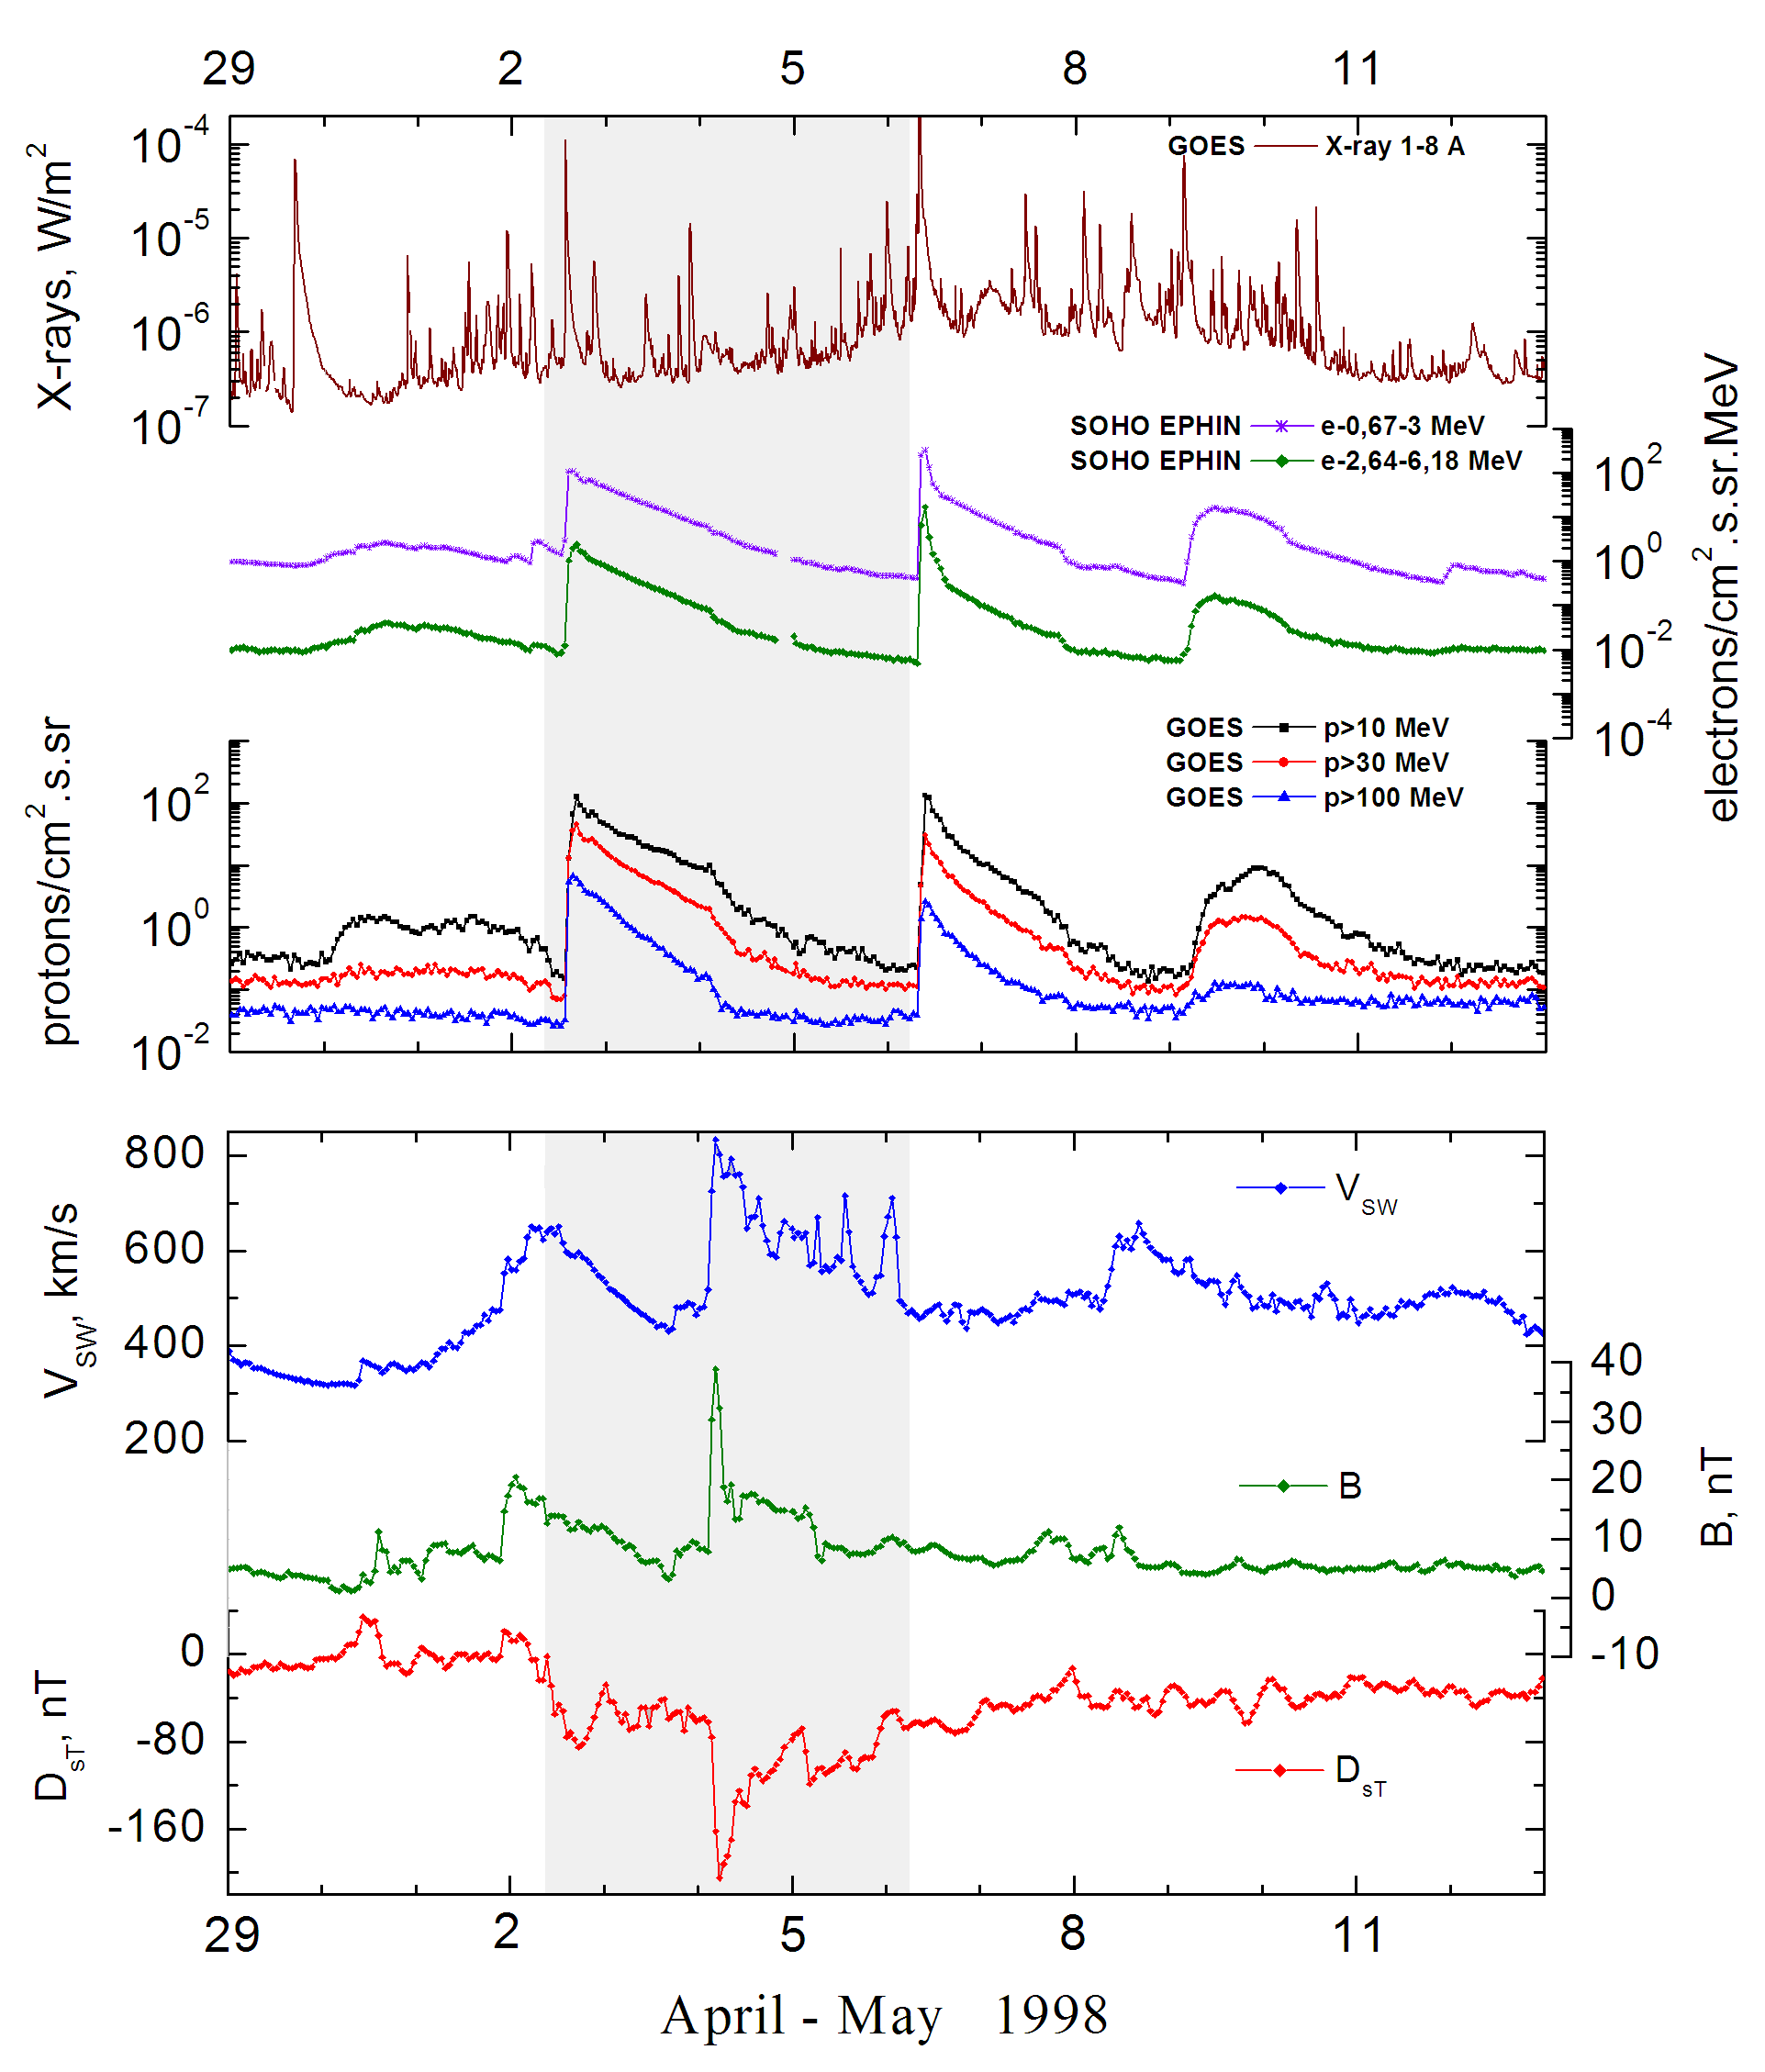

Integral time-of-maximum proton spectrum 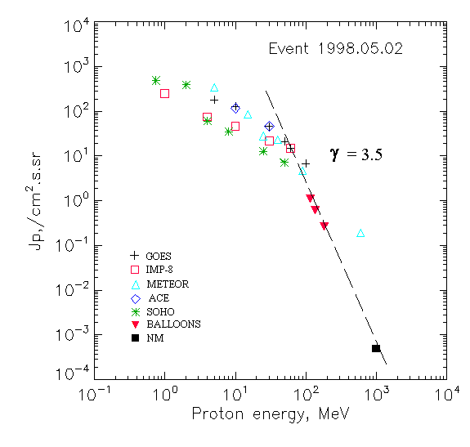

Integral fluxes of protons for the event of 1998 May 02

S/c, instruments | Eр,  MeV | To | Tmax | Jmax,  /cm².s.sr | Dura-tion | Comments
GOES-9
EPS | >5 | 14^{h} | 16^{h} | 181 | 3d
EPS | >10 | 14^{h} | 16^{h} | 130 | 3d
EPS | >30 | 14^{h} | 16^{h} | 46 | 3d
EPS | >50 | 14^{h} | 16^{h} | 21 | 3d
EPS | >60 | 14^{h} | 16^{h} | 15 | 3d
EPS | >100 | 14^{h} | 15^{h} | 6.8 | 2d
METEOR-2
CBM | >5 | 14^{h} | 16^{h} | 343 | 2.9d
CBM | >15 | 14^{h} | 17^{h} | 87 | 2.4d
CBM | >25 | 14^{h} | 17^{h} | 28 | 2d
CBM | >40 | 14^{h} | 15^{h} | 23 | 1.9d
BP | >90 | 14^{h} | 15^{h} | >4.7 | 1.7d
ChD | >600 | 14^{h} | <17^{h} | 0.19 | 1.1d
IMP-8
CPME | >1 | 14^{h} | 21^{h} | 250 | 4d
CPME | >4 | 14^{h} | 19^{h} | 75 | 3d
CPME | >10 | 14^{h} | 18^{h} | 47 | 3d
CPME | >30 | 14^{h} | 17^{h} | 22 | 3d
CPME | >60 | 14^{h} | 16^{h} | 15 | 3d
ACE
SIS | >10 | 14^{h} | 17^{h} | 116 | 3d
SIS | >30 | 14^{h} | 16^{h} | 47 | 3d
SOHO
EPHIN (INT) | >50 | 14^{h} | 16^{h} | 7.2 | 2,5d
BALLOONS
Mi | >116 |  | 3d(07^{h}-08^{h}) | 1.1 |  | After
Mi | >136 |  | 3d(07^{h}-08^{h}) | 0.61 |  | maximum
Mi | >183 |  | 3d(07^{h}-08^{h}) | 0.26
NM
Network | >1000 |  | 15^{h} | 4.9⁻⁰⁴

Differential fluxes of protons for the event of 1998 May 02

S/c, instrument | ∆Е, MeV | To | Tmax | Jmax. /cm².s.sr.MeV | Dura-tion | Comments
IMP-8
CPME | 1-2 | 14^{h} | 03d04^{h} | 131 | 3d
CPME | 2-4.6 | 15^{h} | 21^{h} | 29 | 3d
CPME | 4.6-15 | 14^{h} | 18^{h} | 2,9 | 3d
CPME | 15-25 | 15^{h} | 20^{h} | 1,4 | 3d
CPME | 25-48 | 15^{h} | 17^{h} | 0,8 | 3d
CPME | 48-96 | 14^{h} | 18^{h} | 0,5 | 2,8d
CPME | 96-145 | 14^{h} | 16^{h} | 0,08 | 2,8d
CPME | 145-440 | 14^{h} | 15^{h} | 0,03 | 2,8d
SOHO
LION | 0.75-2 | 15^{h} | 21^{h} | 280 | 3,5d
LION | 2-6 | 15^{h} | 21^{h} | 67 | 4d
EPHIN | 4-8 | 14^{h} | 20^{h} | 6.5 | 3,5d
EPHIN | 8-25 | 15^{h} | 19^{h} | 1.3 | 3,5d
EPHIN | 25-41 | 14^{h} | 16^{h} | 0.22 | 3,5d
EPHIN | 41-53 | - “ - | - “ - | - “ - | - “ -

References
Timofeev V.E. and S.A. Starodubtsev. Solar energetic particle events at the rise phase of the 23rd solar activity cycle registered aboard the spacecraft Interball-2. – Proc. 26th Int. Cosmic Ray Conf., Salt Lake City, USA, 1999, v.6, p.200-203.
Danilova O.A., M.I. Tyasto, E.V. Vashenyuk, B.B. Gvozdevsky, H. Kananen, P. Tanskanen. The GLE of May 2, 1998: An Effect of Disturbed Magnetosphere on Solar Cosmic Rays. - Proc. 26th Int. Cosmic Ray Conf., Salt Lake City, USA, 1999, v.6, p.399-402.
Данилова О.А., М.И. Тясто, Э.В. Вашенюк, и др.,2002.
А.В. Белов, Э.В. Вашенюк, Е.А. Ерошенко, др., 2000.
Dietrich W. and C. Lopate. Measurements of iron reach SEP events using the University of Chicago IMP-8 instrument. - Proc. 26th Int. Cosmic Ray Conf., Salt Lake City, USA, v.6, 71-74, 1999.
Skoug R.M., S.J. Bame, W.C. Feldman, et.al., 1999.
Struminsky A.B. Prolonged release of > 100 MeV protons from local radiation belts of the Sun. – Proc. 26th Annual Seminar “Physics of Auroral Phenomena”, Apatity, Russia, p.162-165, 2003.
Roussev I. I., I. V. Sokolov, T. G. Forbes, et.al., 2004

