Event 1998.05.06 – (1998-126)

Particle event: To(Ep>10 MeV) – 06d08^{h}
Tmax(Ep>10 MeV) – 06d09^{h}, Jmax (Ep>10 MeV) – 120 /cm².s.sr
Duration of the event – 2 days
Energy of the SCR and 0.1 GCR fluxes balance – Eb = 575 MeV

Sources: ● solar flare 06d07^{h}58^{m}, X2.7/1N, S15W64, АR8210
Main burst X-ray 1-8 Ǻ: onset – 06d07^{h}58^{m}, max – 06d08^{h}09^{m}, Ф = 0.21 J/m²
CME: 06d08^{h}29^{m}, V = 1099 km/s, Δφ = 190º, dA=309º;
ΔSC 08d09^{h}52^{m}

Particle fluxes and associated phenomena
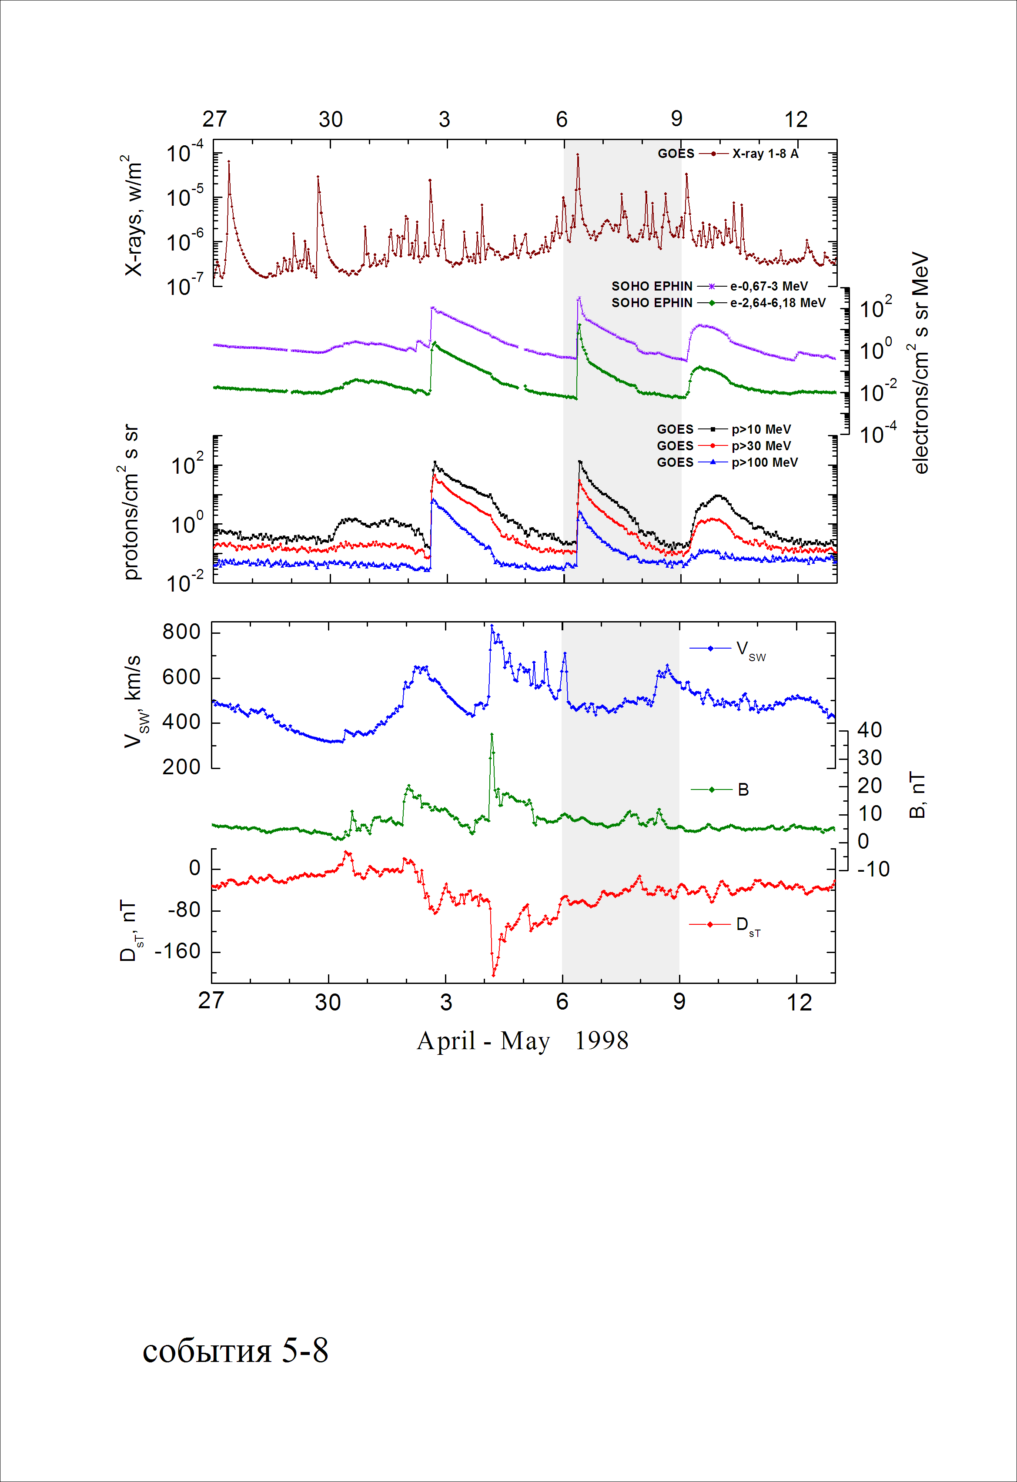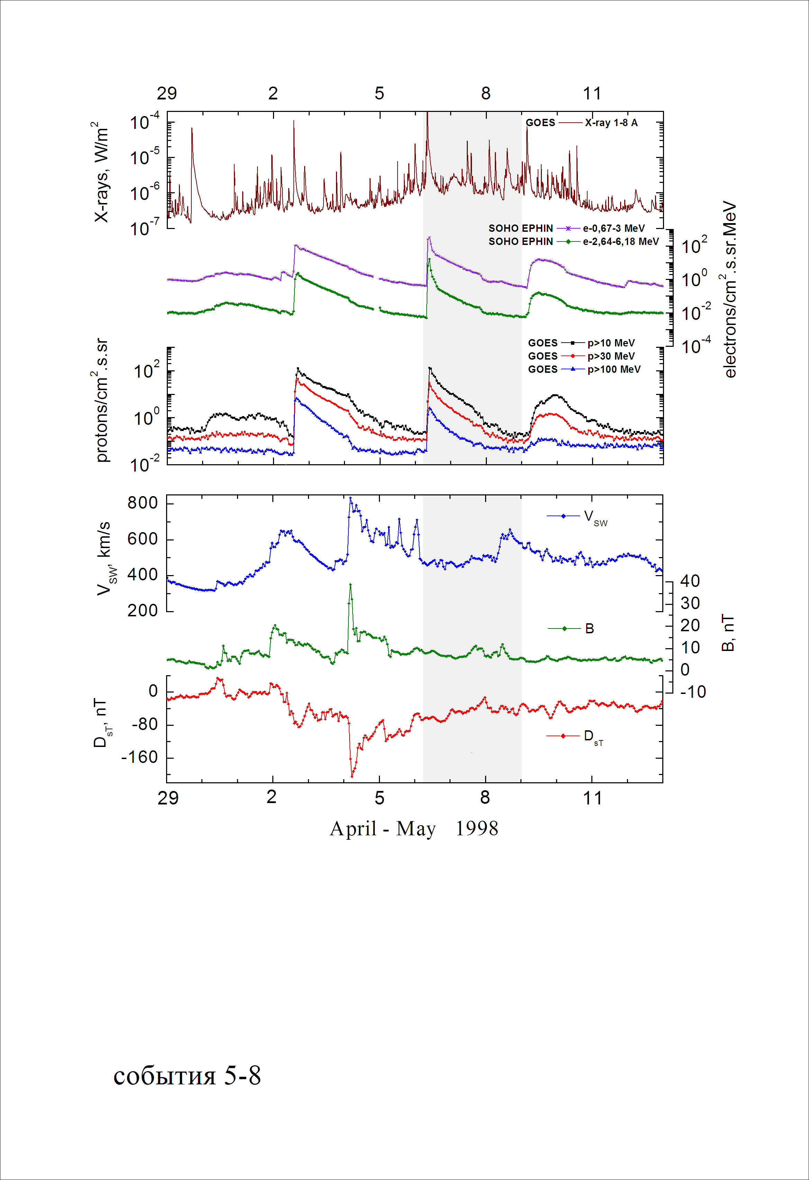

Integral time-of-maximum proton spectrum 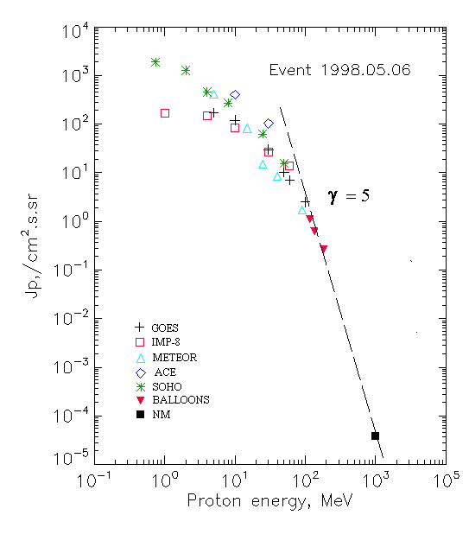

Integral fluxes of protons for the event of 1998 May 06

S/c, instruments | Eр, MeV | To | Tmax | Jmax,  /cm².s.sr | Dura-tion | Comments
GOES-9
EPS | >5 | 08^{h} | 10^{h} | 171 | 2d
EPS | >10 | 08^{h} | 09^{h} | 120 | 2d
EPS | >30 | 08^{h} | 09^{h} | 30.1 | 2d
EPS | >50 | 08^{h} | 09^{h} | 10.3 | 2d
EPS | >60 | 08^{h} | 09^{h} | 7.0 | 2d
EPS | >100 | 08^{h} | 09^{h} | 2.5 | 2d
METEOR-2
CBM | >5 | 08^{h} | 09^{h} | 414 | 3d
CBM | >15 | 08^{h} | 09^{h} | 82 | 2d
CBM | >25 | 08^{h} | 09^{h} | 15 | 1.5d
CBM | >40 | 08^{h} | 09^{h} | 8,4 | 1d
BP | >90 | 08^{h} | 09^{h} | 1,7 | 1d
ChD | >600 | - | - | - | -
IMP-8
CPME | >1 | 08^{h} | 11^{h} | 170 | 2.5d
CPME | >4 | 08^{h} | 10^{h} | 146 | 2.5d
CPME | >10 | 08^{h} | 09^{h} | 84 | 2.5d
CPME | >30 | 08^{h} | 09^{h} | 26.9 | 2.5d
CPME | >60 | 08^{h} | 09^{h} | 13.8 | 2.5d
ACE
SIS | >10 | 08^{h} | 09^{h} | 402 | 2.5d
SIS | >30 | 08^{h} | 09^{h} | 103 | 2.5d
SOHO
EPHIN (INT) | >50 | 09^{h} | 09^{h} | 15,4 | 2d
BALLOONS
Mi | >116 |  | 3d(07^{h}-08^{h}) | 1.1
Mi | >136 |  | 3d(07^{h}-08^{h}) | 0.61
Mi | >183 |  | 3d(07^{h}-08^{h}) | 0.26
NM
Network | >1000 |  | 09^{h} | 3.8•10⁻⁵

Differential fluxes of protons for the event of 1998 May 06

S/c, instrument | ∆Е, MeV | To | Tmax | Jmax. /cm².s.sr.MeV | Dura-tion) | Comments
IMP-8
CPME | 1-2 | 11^{h} | 15^{h} | 187 | 3d
CPME | 2-4.6 | 08^{h} | 11^{h} | 27 | 3d
CPME | 4.6-15 | 08^{h} | 10^{h} | 9.3 | 3d
CPME | 15-25 | 08^{h} | 09^{h} | 4.65 | 3d
CPME | 25-48 | 08^{h} | 09^{h} | 0.65 | 3d
CPME | 48-96 | 08^{h} | 09^{h} | 0.12 | 3d
CPME | 96-145 | 08^{h} | 09^{h} | 0.15 | 3d
CPME | 145-440 | 08^{h} | 09^{h} | 0.02 | 2.5d
SOHO
LION | 0,75-2 | 09^{h} | 16^{h} | 1140 | 3d
LION | 2-6 | 09^{h} | 14^{h} | 204 | 2.5d
EPHIN | 4-8 | 09^{h} | 11^{h} | 46 | 2.5d
EPHIN | 8-25 | 09^{h} | 11^{h} | 12.5 | 2.5d
EPHIN | 25-41 | 08^{h} | 10^{h} | 2,1 | 2.5d
EPHIN | 41-53 | - “ - | - “ - | - “ - | - “ -

References
Dietrich W. and C. Lopate. Measurements of iron reach SEP events using the University of Chicago IMP-8 instrument. - Proc. 26th Int. Cosmic Ray Conf., Salt Lake City, USA, v.6, 71-74, 1999.
Reames D.V., C.K. Ng and A.J. Tylka. 2000.
A.B. Struminsky. Prolonged release of > 100 MeV protons from local radiation belts of the Sun. – Proc. 26th Annual Seminar “Physics of Auroral Phenomena”, Apatity, Russia, p.162-165, 2003
Miroshnichenko L.I. and J. Perez-Peraza. 2008.

