Event 1998.05.09 – (1998-129)

Particle event: To(Ep>10 MeV) – 09d06^{h}
Tmax₁(Ep>10 MeV) – 09d13^{h}, Jmax₁ (Ep>10 MeV) – 4.7 /cm².s.sr
Tmax₂(Ep>10 MeV) – 09d23^{h}, Jmax₂ (Ep>10 MeV) – 8.9 /cm².s.sr
Duration of the event – 2.5 days
Energy of the SCR and 0.1 GCR fluxes balance – Eb(max₁) = 230 MeV
– Eb(max₂) = 230 MeV

Sources: ■ solar flare 09d03^{h}04^{m}, M7.7/ -, S15W90, АR8210 ~ one day behind the W-limb burst X-ray 1-8 Ǻ: onset – 09d03^{h}04^{m}, max – 09d03^{h}40^{m}, Ф = 0.11 J/m²
CME: 09d03^{h}35^{m}, V = 2331 km/s, Δφ = 178º, dA = 262º;

Particle fluxes and associated phenomena

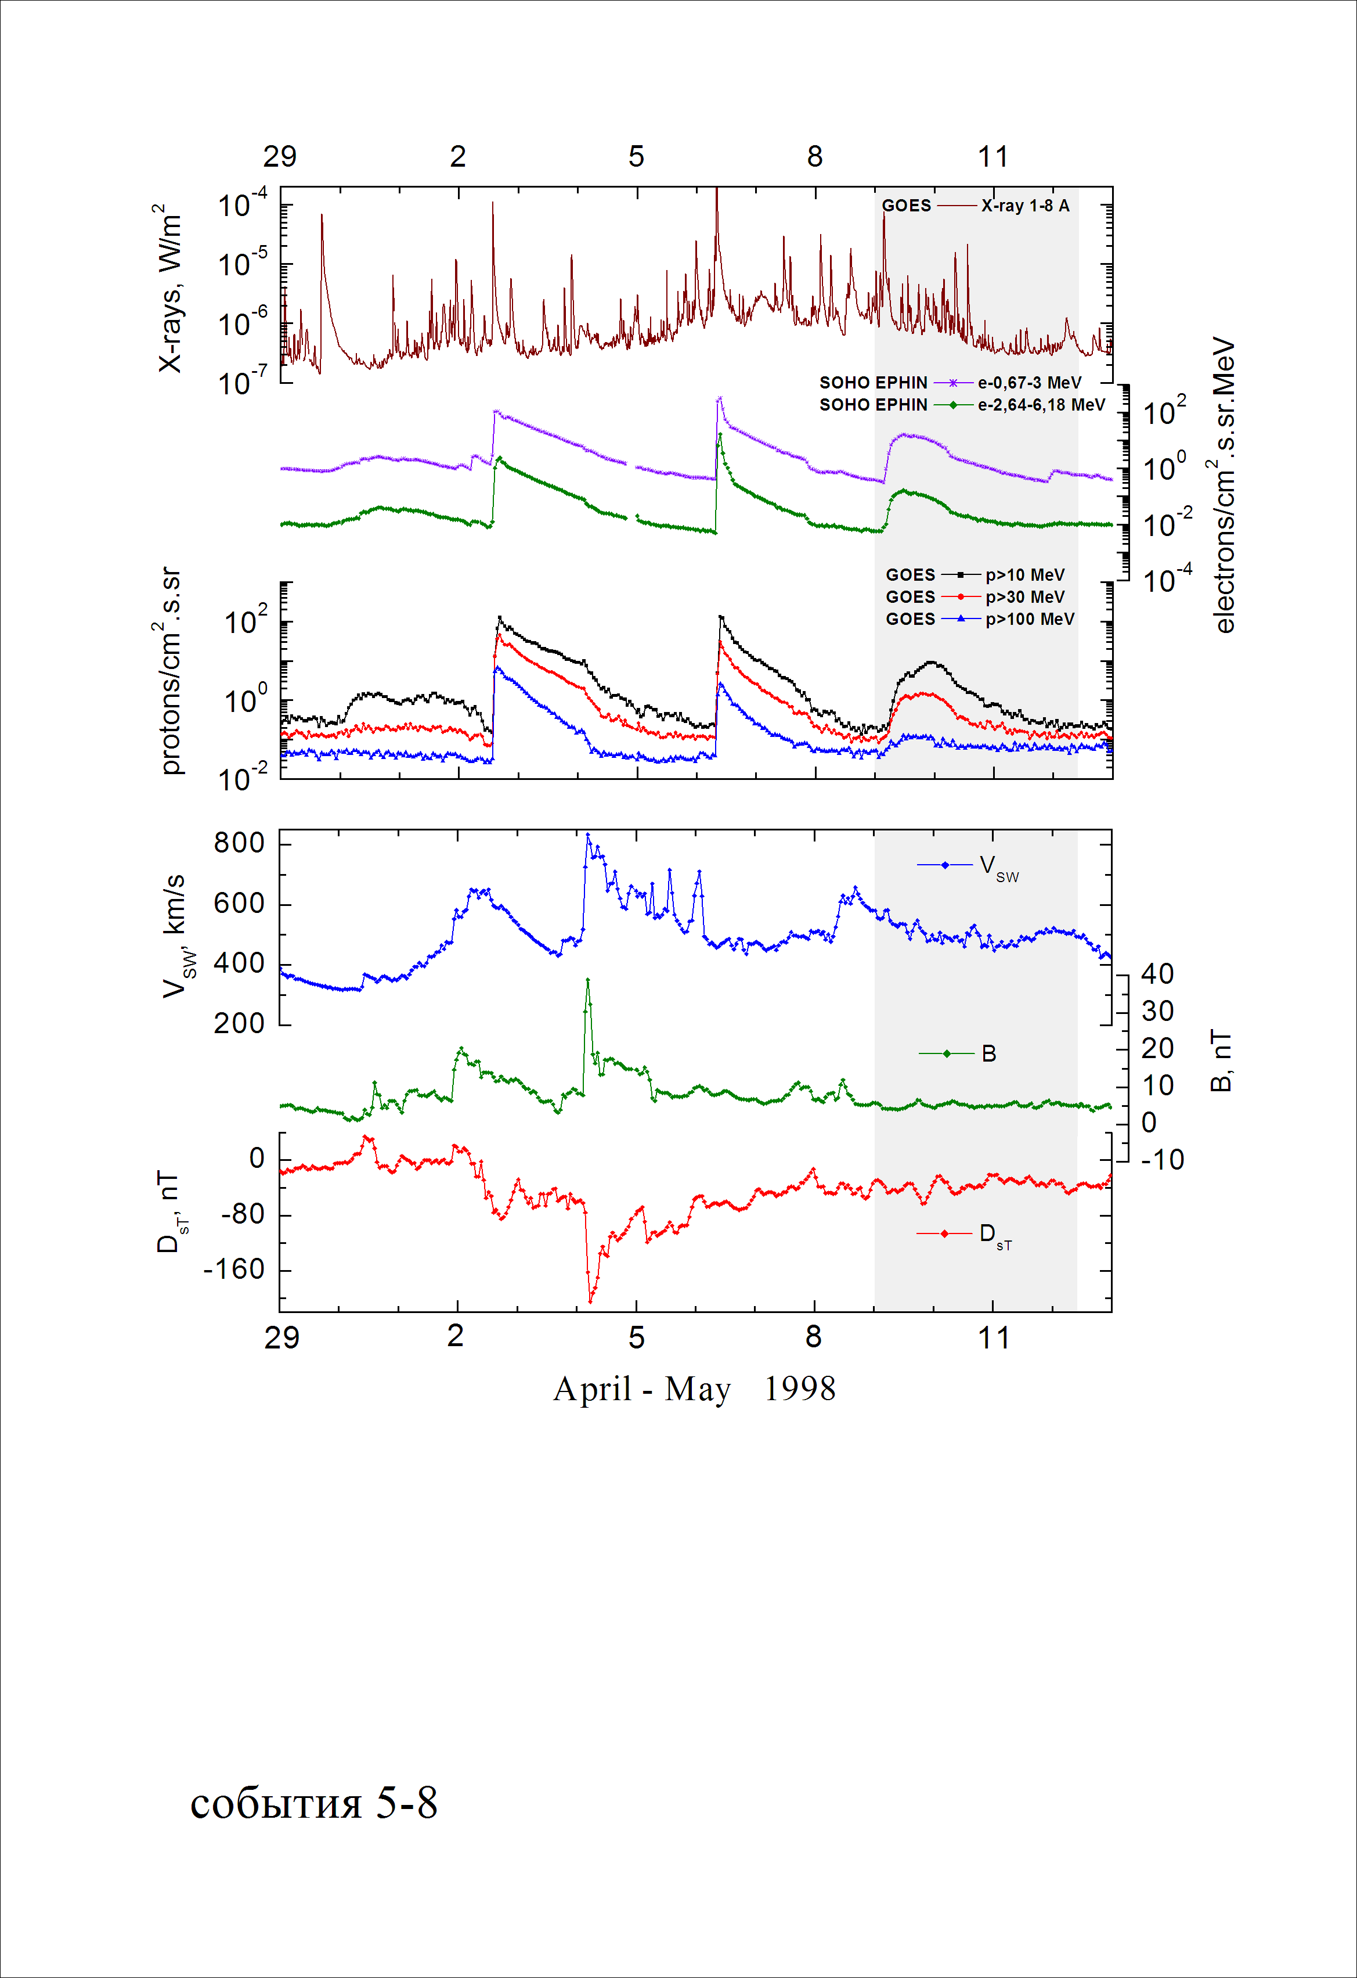

Integral time-of-maximum proton spectrum 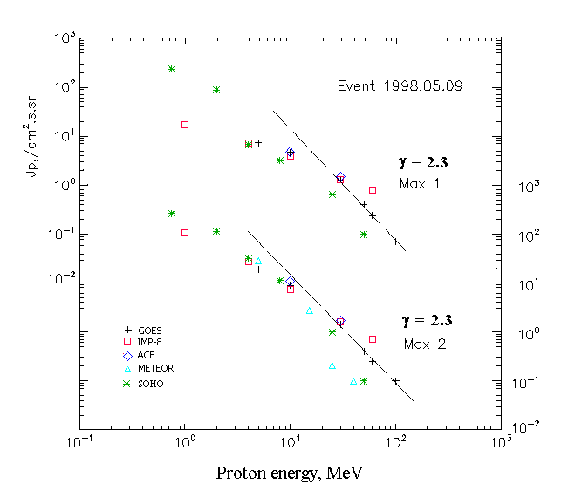

Integral fluxes of protons for the event of 1998 May 09

S/c, instruments | Eр, MeV | To | Tmax | Jmax,  /cm².s.sr | Dura-tion | Comments
GOES-9
EPS | >5 | 06^{h} | 13^{h}/23^{h} | 7.3/19 | 2.5d
EPS | >10 | 06^{h} | 13^{h}/23^{h} | 4.7/8.9 | 2.5d
EPS | >30 | 06^{h} | 13^{h}/22^{h} | 1.3/1.4 | 2.5d
EPS | >50 | 06^{h} | 12^{h}/20^{h} | 0.4/0.4 | 2.5d
EPS | >60 | 08^{h} | 12^{h}/20^{h} | 0.24/0.25 | 2d
EPS | >100 | 08^{h} | 11^{h}/20^{h} | 0.07/0.1 | 2d
METEOR-2
CBM | >5 | <17^{h} | - /18^{h} | - /28 | 3d
CBM | >15 | <17^{h} | - /18^{h} | - /2.9 | 2d
CBM | >25 | <17^{h} | - /17^{h} | - /0.18 | 1d
CBM | >40 | <17^{h} | - /17^{h} | - /0.09 | 1d
BP | >90 | - | - | - | -
ChD | >600 | - | - | - | -
IMP-8
CPME | >1 | 05^{h} | 12^{h}/10d01^{h} | 17.2/105 | 5d
CPME | >4 | 05^{h} | 12^{h}/10d01^{h} | 7.2/27 | 3.5d
CPME | >10 | 05^{h} | 12^{h}/10d00^{h} | 4.0/7.3 | 3.5d
CPME | >30 | 05^{h} | 12^{h}/21^{h} | 1.3/1.6 | 3.5d
CPME | >60 | 05^{h} | 12^{h}/20^{h} | 0.8/0.7 | 3.5d
ACE
SIS | >10 | 05^{h} | 12^{h}/23^{h} | 4.8/10.7 | 2d
SIS | >30 | 05^{h} | 12^{h}/19^{h} | 1.3/1.7 | 2d
SOHO
EPHIN (INT) | >50 | 04^{h} | 11^{h}/21^{h} | 0.1/0.1 | 1d

Differential fluxes of protons for the event of 1998 May 09

S/c, instruments | ∆Е, MeV | To | Tmax | Jmax. /cm².s.sr.MeV | Dura-tion | Comments
IMP-8
CPME | 1-2 | 08^{h} | - /10d01^{h} | - /45 | 3.5d
CPME | 2-4,6 | 07^{h} | - /10d01^{h} | - /16 | 3.5d
CPME | 4,6-15 | 06^{h} | - /10d00^{h} | - /1.74 | 3d
CPME | 15-25 | 06^{h} | - /10d00^{h} | - /0.3 | 3d
CPME | 25-48 | 05^{h} | - /21^{h} | - /0.04 | 2.5d
CPME | 48-96 | 06^{h} | - /17^{h} | - /0.01 | 2.5d
CPME | 96-145 | 05^{h} | - /21^{h} | - /0.01 | 1.5d
CPME | 145-440 | 05^{h} | - /11^{h} | - /0.003 | 1.5d
SOHO
LION | 0,75-2 | 05^{h} | 12^{h}/10d01^{h} | 13/85 | 4d
LION | 2-6 | 06^{h} | 12^{h}/10d01^{h} | 4/20 | 4d
EPHIN | 4-8 | 05^{h} | 11^{h}/23^{h} | 0.9/5 | 4d
EPHIN | 8-25 | 05^{h} | 11^{h}/21^{h} | 0.15/0.6 | 4d
EPHIN | 25-41 | 05^{h} | 11^{h}/21^{h} | 0.026/0.04 | 3d
EPHIN | 41-53 | - “ - | - “ - | - “ - | - “ -

References
W. Dietrich and C. Lopate. Measurements of iron reach SEP events using the University of Chicago IMP-8 instrument. - Proc. 26th Int. Cosmic Ray Conf., Salt Lake City, USA, v.6, 71-74, 1999.
Есть слабое указание на регистрацию нейтронов от вспышки 8 мая 1998 г. на НМ в Алма-Ате (Аушев и др., 1999, 26-ая МККЛ) от той же активной области, но эти наблюдения, видимо, не связаны с СПС 9 мая.

