Event 1998.06.16 – (1998-167)

Particle event: To(Ep>10 MeV) – 16d21^{h}
Tmax₁(Ep>10 MeV) –17d09^{h}, Jmax₁ (Ep>10 MeV) – 1.3 /cm².s.sr
Tmax₂(Ep>10 MeV) –18d02^{h}, Jmax₂ (Ep>10 MeV) – 1.4 /cm².s.sr
Duration of the event – 3 days
Energy of the SCR and 0.1 GCR fluxes balance – Eb(max₁) = 80 MeV
– Eb(max₂) = 75 MeV
Sources:  solar flare 16d18^{h}03^{m}, M1.0/ - , S22W90, АR8232 one day behind the W-limb
Main burst X-ray 1-8 Å: onset – 16d18^{h} 03^{m}, max – 16d18^{h} 42^{m}, Ф = 0.037 J/m²
CME: 16d18^{h}27^{m}, V = 1484 km/s, Δφ = 281º, dA = 278º;

Particle fluxes and associated phenomena
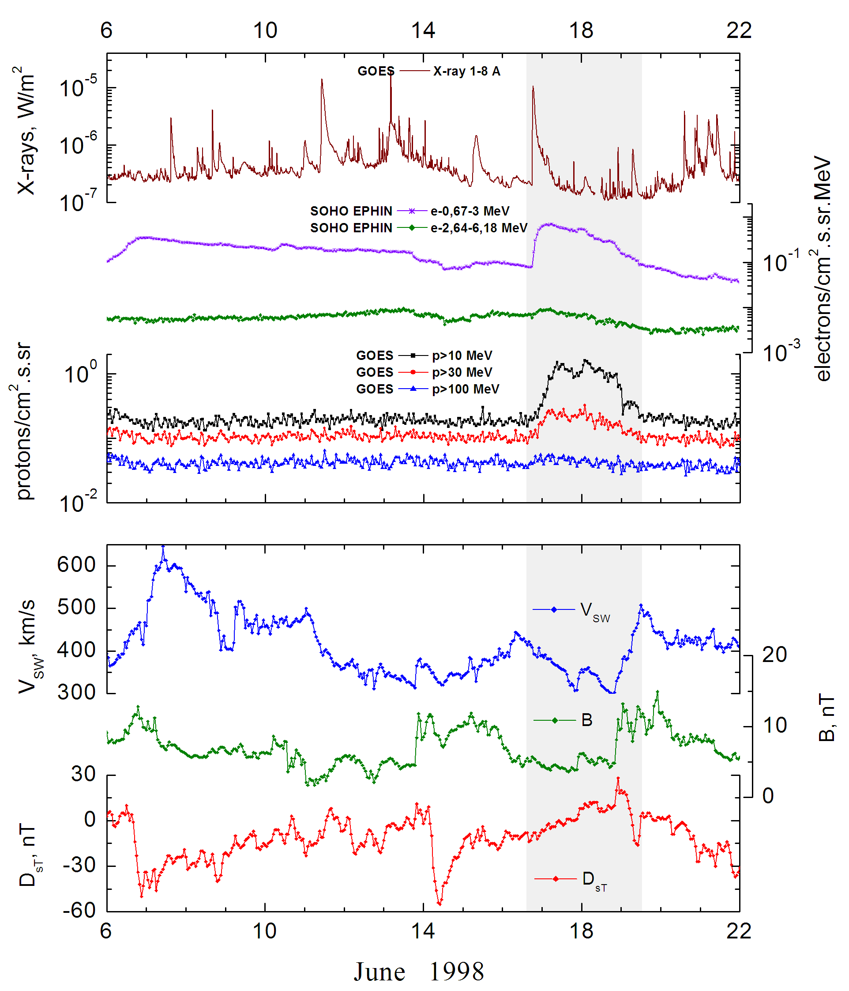
Integral time-of-maximum proton spectrum
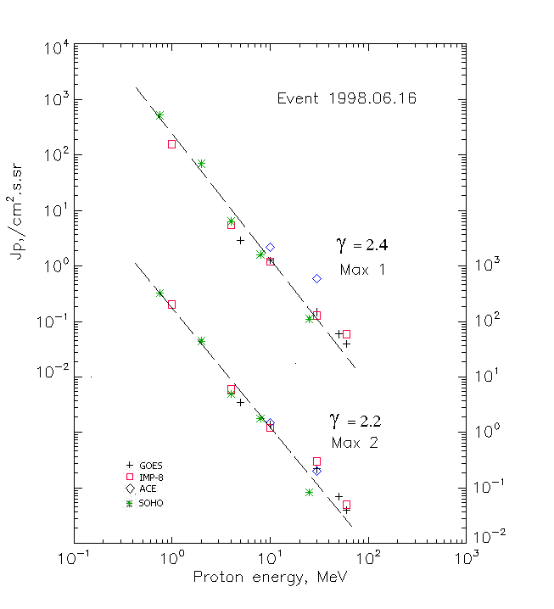

Integral fluxes of protons for the event of 1998 June 16

S/c, instruments | Eр, MeV | To | Tmax | Jmax,  /cm².s.sr | Dura-tion | Comments
GOES-9
EPS | >5 | - | 17d09^{h}/18d05^{h} | 2.9/3.5 | 3d
EPS | >10 | - | 17d09^{h}/18d02^{h} | 1.3/1.4 | 3d
EPS | >30 | - | 17d09^{h}/18d02^{h} | 0.15/0.22 | 2d
EPS | >50 | - | 17d04^{h}/18d02^{h} | 0.06/0.07 | 2d
EPS | >60 | - | 17d04^{h}/18d02^{h} | 0.04/0.04 | -
EPS | >100 | - | - | - | -
IMP-8
CPME | >1 | 20^{h} | 17d10^{h}/18d01^{h} | 157/200 | 6d
CPME | >4 | 20^{h} | 17d10^{h}/18d01^{h} | 5.5/6 | 5d
CPME | >10 | 20^{h} | 17d10^{h}/18d01^{h} | 1.2/1.2 | 5d
CPME | >30 | 20^{h} | 17d10^{h}/18d01^{h} | 0.13/0.3 | 2d
CPME | >60 | 20^{h} | 17d09^{h}/18d01^{h} | 0.06/0.05 | 2d
ACE
SIS | >10 | 20^{h} | 17d10^{h}/18d01^{h} | 2.2/1.5 | 2d
SIS | >30 | 20^{h} | 17d10^{h}/18d01^{h} | 0,6/0.2 | 2d
SOHO
EPHIN (INT) | >50 | - | 17d10^{h}/18d03^{h} | - | -
Differential fluxes of protons for the event of 1998 June 16

S/c, instruments | ∆Е, MeV | To | Tmax | Jmax. /cm².s.sr.MeV | Dura-tion | Comments
IMP-8
CPME | 1-2 | 23^{h} | 18d01^{h}/18d23^{h} | 178/184 | 4.5d
CPME | 2-4.6 | 23^{h} | 17d11^{h}/18d23^{h} | 12.5/8.6 | 4.5d
CPME | 4.6-15 | 21^{h} | 18d01^{h}/ - | 0.3/ - | 4.5d
CPME | 15-25 | 23^{h} | 17d15^{h}/ - | 0.05/ - | 4.5d
CPME | 25-48 | 23^{h} | 17d23^{h}/ - | 0.01/ - | 4.5d
CPME | 48-96
CPME | 96-145
CPME | 145-440
SOHO
LION | 0,75-2 | 23^{h} | 17d16^{h}/18d23^{h} | 330/225 | 5d
LION | 2-6 | 23^{h} | 17d16^{h}/18d23^{h} | 26/9.8 | 5d
EPHIN | 4-8 | 21^{h} | 17d10^{h}/18d03^{h} | 1.2/0.8 | 5d
EPHIN | 8-25 | 20^{h} | 17d10^{h}/18d03^{h} | 0.09/0.1 | 5d
EPHIN | 25-41 | 20^{h} | 17d10^{h}/18d03^{h} | 0.004/0.003 | 5d
EPHIN | 41-53 | - “ - | - “ - | - “ - | - “ -

References
No information on publications, excepting for:
http://www.swpc.noaa.gov/ftpdir/indices/SPE.txt

