Event 1998.09.30 – (1998-273)

Particle event: To(Ep>10 MeV) – 30d14^{h}
Tmax(Ep>10 MeV) – 30d23^{h}, Jmax (Ep>10 MeV) – 785 /cm².s.sr
Duration of the event – 3 days
Energy of the SCR and 0.1 GCR fluxes balance – Eb = 600 MeV

Sources: ● solar flare 30d13^{h}08^{m}, M2.8/2N, N23W78, АR8340
Main burst X-ray 1-8Å: onset – 30d13^{h}08^{m}, max – 30d13^{h}50^{m}, Ф = 0.11 J/m²
CME: gap

Particle fluxes and associated phenomena
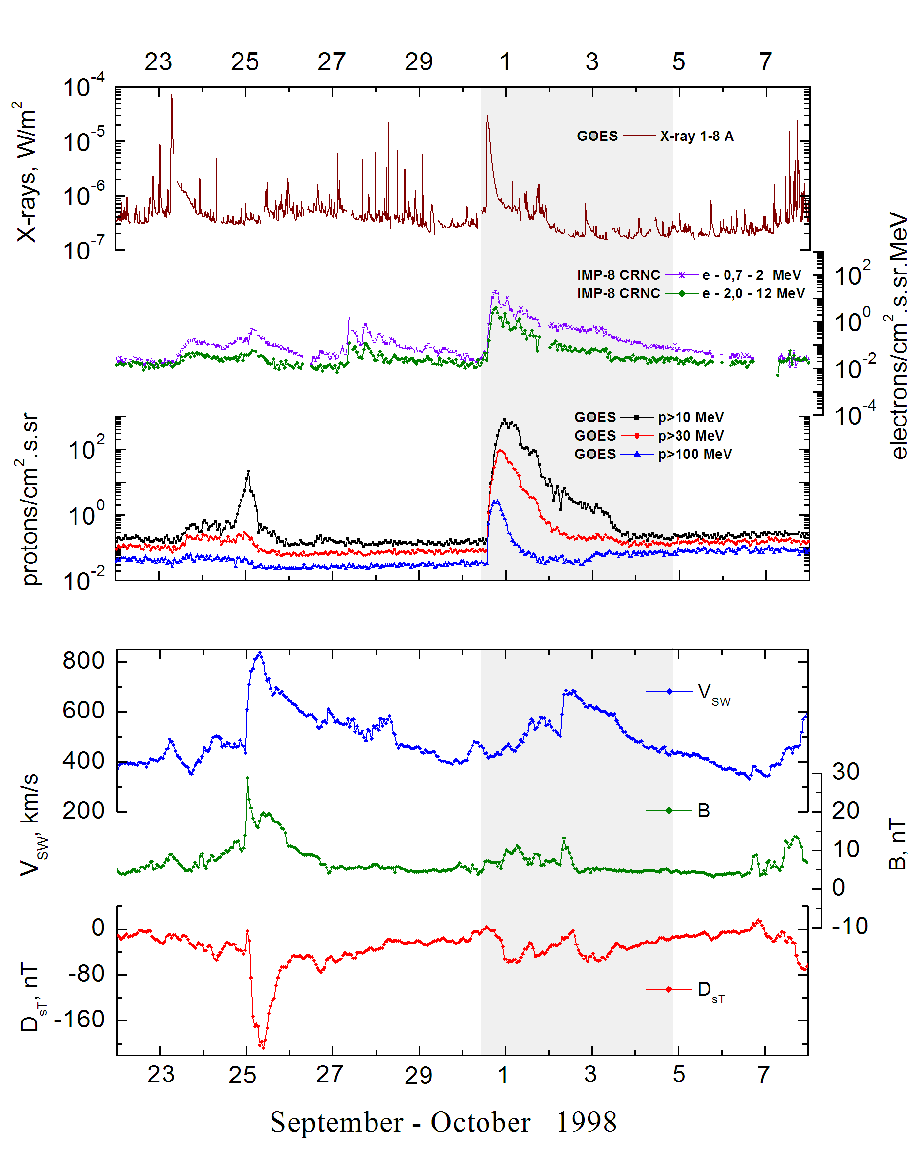
Integral time-of-maximum proton spectrum
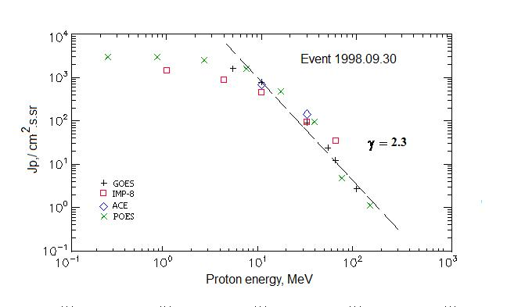

Integral fluxes of protons for the event of 1998 September 30

S/c, instruments | Eр, MeV | To | Tmax | Jmax,  /cm².s.sr | Dura-tion | Comments
GOES-10
EPS | >5 | 14^{h} | 01d03^{h} | 1620 | 3d
EPS | >10 | 14^{h} | 23^{h} | 785 | 3d
EPS | >30 | 14^{h} | 20^{h} | 90 | 3d
EPS | >50 | 14^{h} | 19^{h} | 24 | 2d
EPS | >60 | 14^{h} | 19^{h} | 12.5 | 2d
EPS | >100 | 14^{h} | 19^{h} | 2.7 | 1d
POES-15
MEPED | >0.24 | - | 21^{h} | 3050 | -
MEPED | >0.8 | - | 20^{h} | 2970 | -
MEPED | >2.5 | - | 19^{h} | 2500 | -
MEPED | >6.9 | - | 18^{h} | 1590 | -
MEPED | >16 | - | 18^{h} | 480 | -
MEPED | >36 | - | 17^{h} | 97 | -
MEPED | >70 | - | 17^{h} | 4.8 | -
MEPED | >140 | - | 16^{h} | 1.15 | -
IMP-8
CPME | >1 | 14^{h} | 21^{h} | 1500 | 5d
CPME | >4 | 14^{h} | 21^{h} | 910 | 5d
CPME | >10 | 14^{h} | 21^{h} | 460 | 5d
CPME | >30 | 14^{h} | 20^{h} | 95 | 3d
CPME | >60 | 14^{h} | 20^{h} | 36 | 3d
ACE
SIS | >10 | 14^{h} | 20^{h} | 685 | 3d
SIS | >30 | 14^{h} | 19^{h} | 144 | 3d
SOHO
EPHIN (INT) | >50 | - | - | - | -

Differential fluxes of protons for the event of 1998 September 30

S/c, instruments | ∆Е, MeV | To | Tmax | Jmax  /cm².s.sr.MeV | Dura-tion | Comments
IMP-8
CPME | 1-2 | 15^{h} | 01d15^{h} | 2000 | ∼7d
CPME | 2-4.6 | 15^{h} | 01d15^{h} | 603 | ∼7d
CPME | 4.6-15 | 15^{h} | 21^{h} | 48 | ∼7d
CPME | 15-25 | 15^{h} | 21^{h} | 23 | ∼4d
CPME | 25-48 | 15^{h} | 20^{h} | 3.1 | ∼3d
CPME | 48-96 | 15^{h} | 19^{h} | 0.37 | ∼2d
CPME | 96-145 | - | - | - | -
CPME | 145-440 | - | - | - | -
SOHO |  | Data | absent

References
Dietrich W. and C. Lopate. Measurements of iron reach SEP events using the University of Chicago IMP-8 instrument. - Proc. 26th Int. Cosmic Ray Conf., Salt Lake City, USA, v.6, 71-74, 1999.
Reames D.V., C.K. Ng and A.J. Tylka. 2000.
Leske R.A., R.A. Mewaldt, .C. Cummings, et.al., 2001.

