Event 1998.11.06 – (1998-310)

Particle event: To(Ep>10 MeV) – 06d03^{h}
Tmax(Ep>10 MeV) – 06d12^{h}, Jmax(Ep>10 MeV) – 4.6 /cm².s.sr
Duration of the event – 2 days
Energy of the SCR and 0.1 GCR fluxes balance – Eb = 75 MeV

Sources: ● solar flare 05d19^{h}00^{m}, M8.4/2B, N22W18, АR8375
Main X-ray burst 1-8 Ǻ: onset – 05d19^{h} 00^{m}, max – 05d19^{h}55^{m}, Ф = 0.11 J/m²
CME:05d20^{h}44^{m}, V = 1118 km/s , Δφ = 360º, dA = 300º
ΔSC 07d08^{h}15 ^{m}

Particle fluxes and associated phenomena
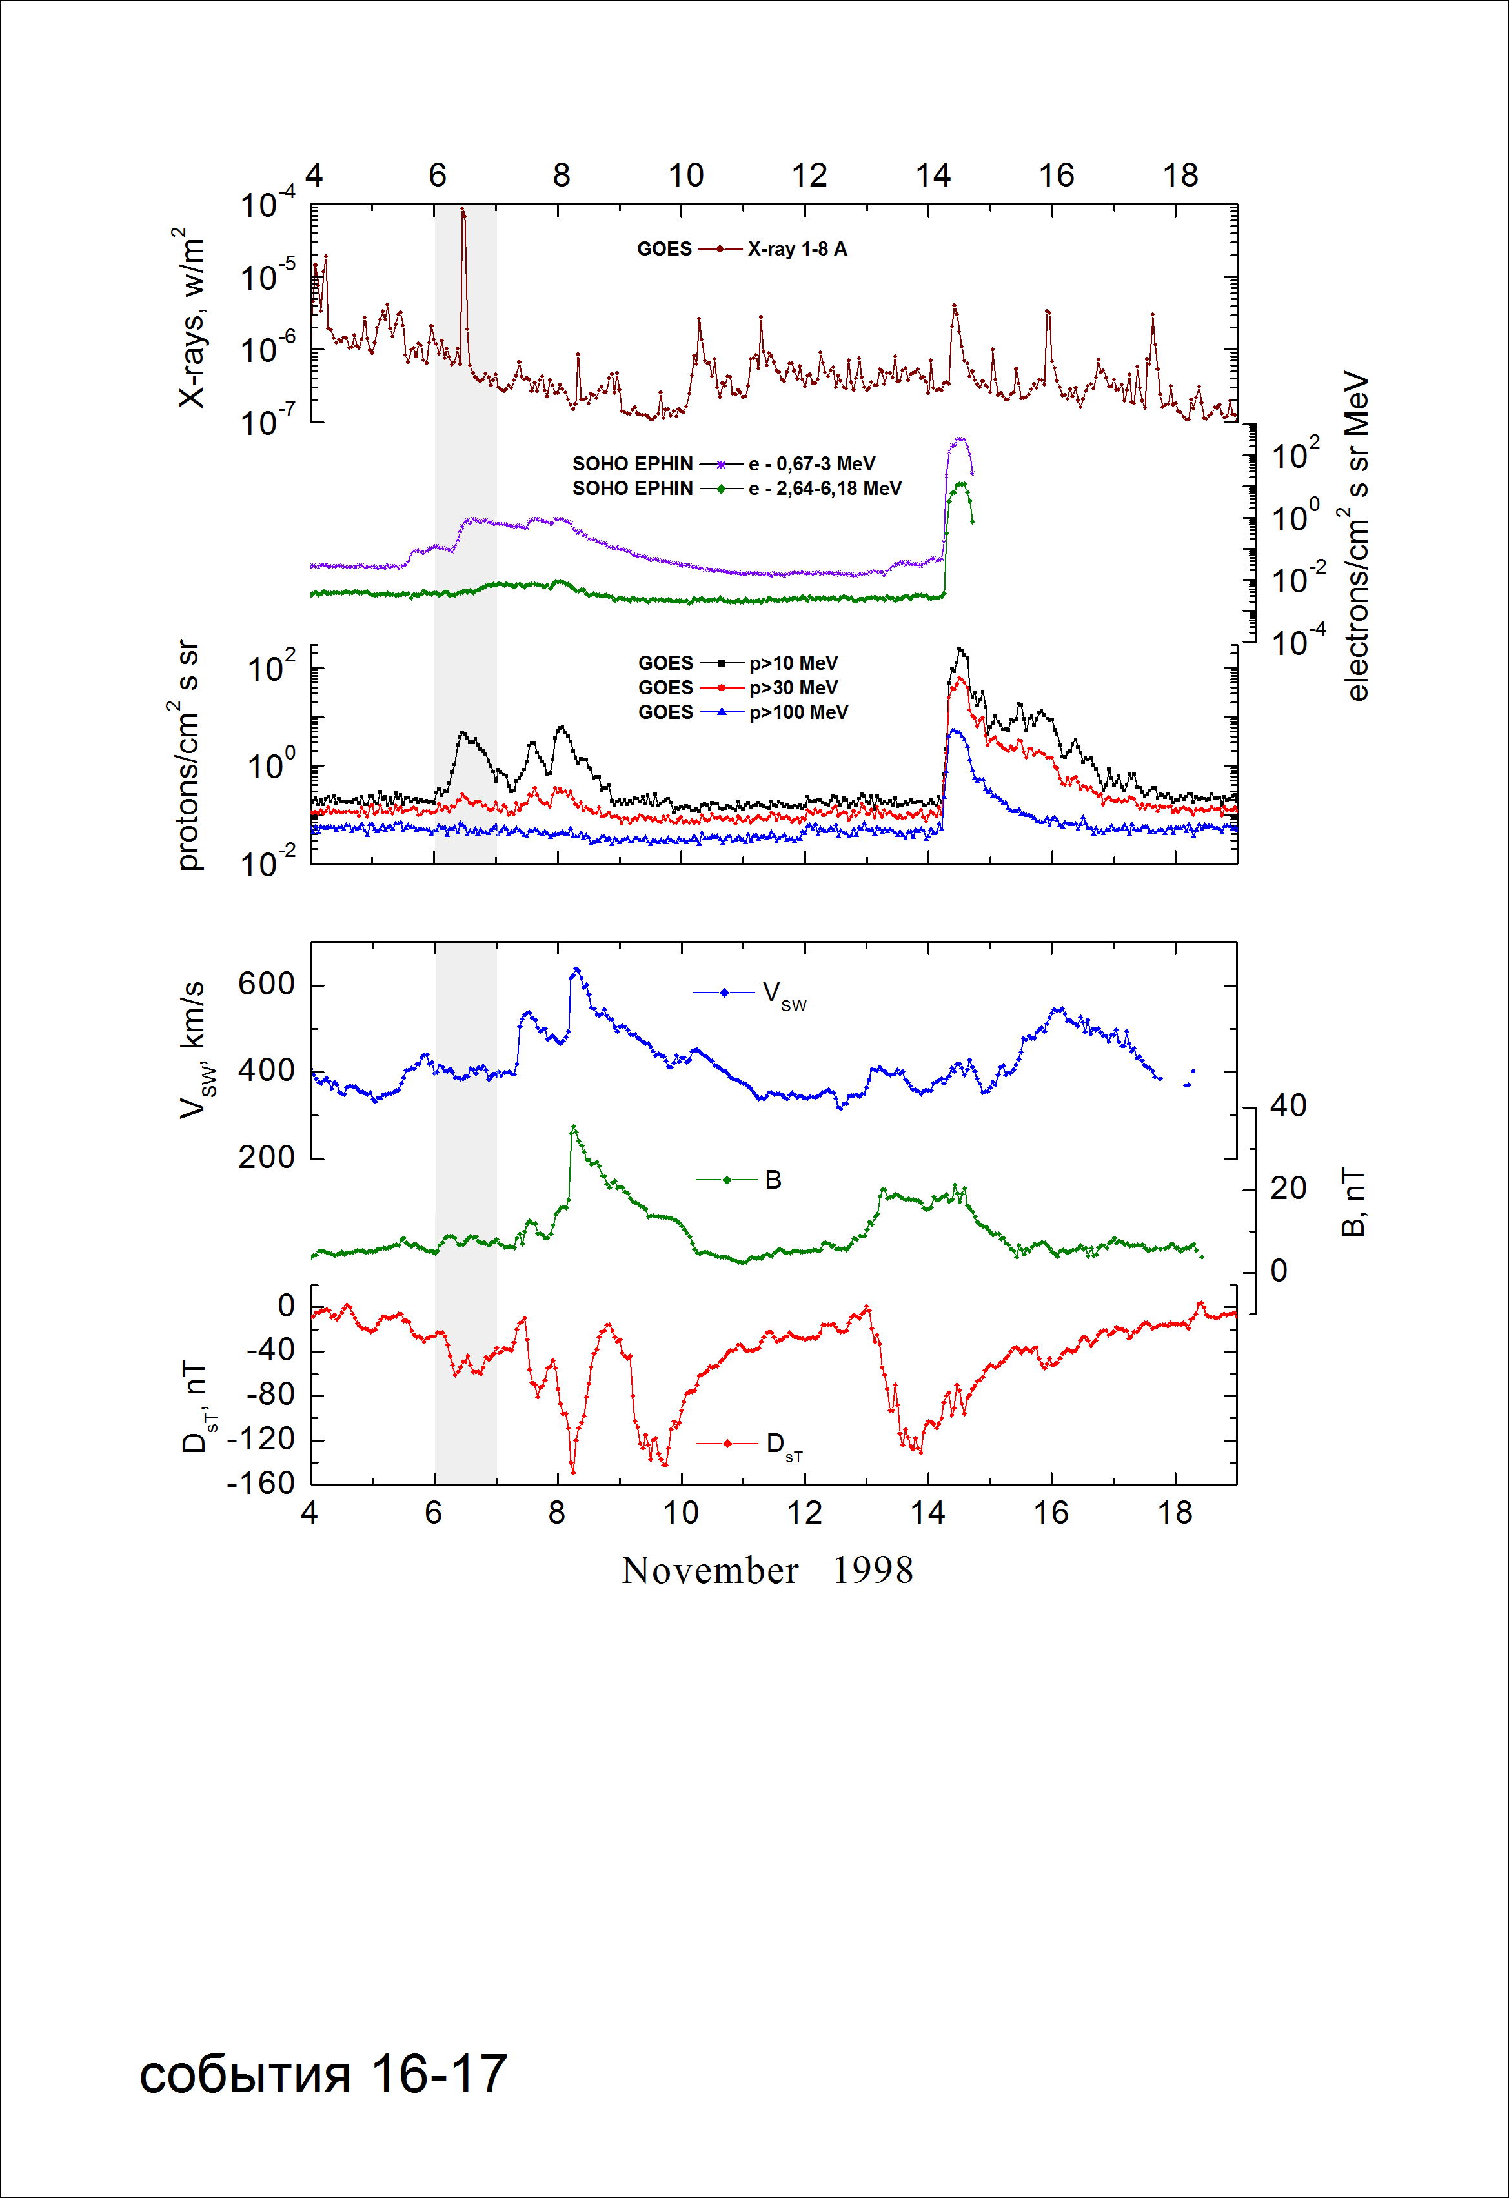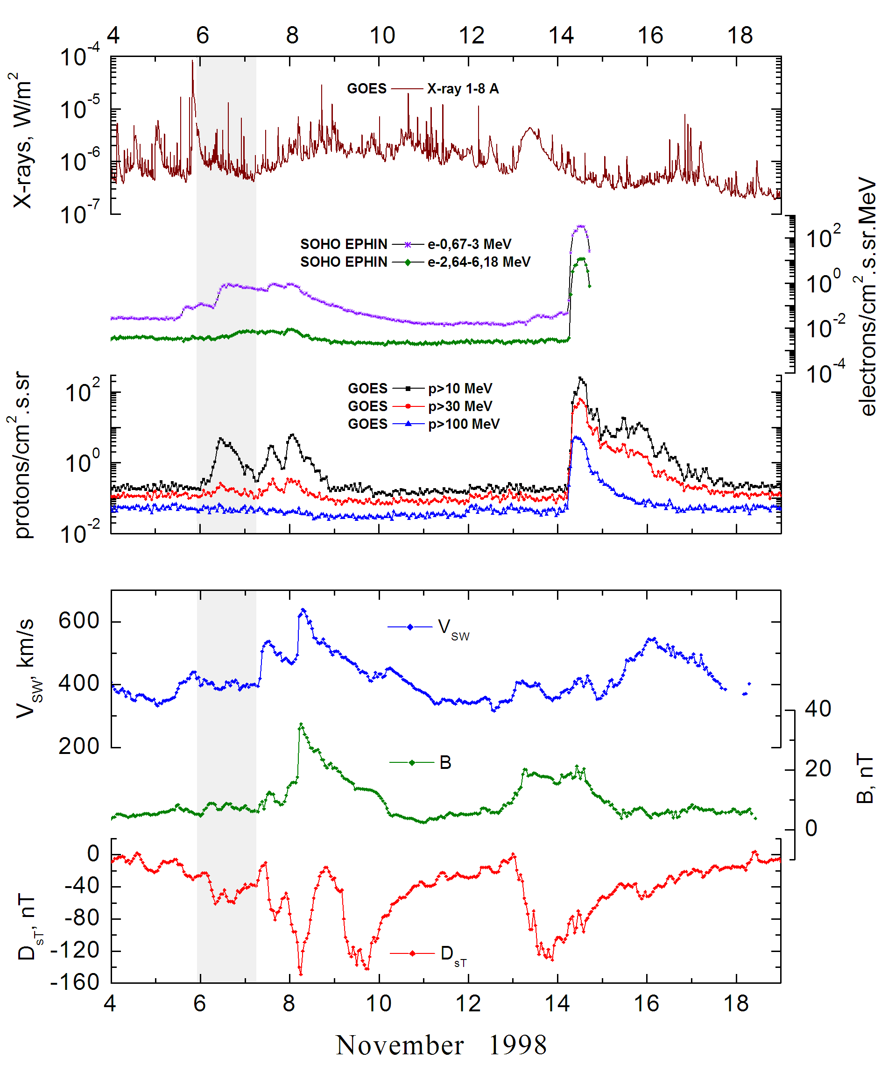
Integral time-of-maximum proton spectrum
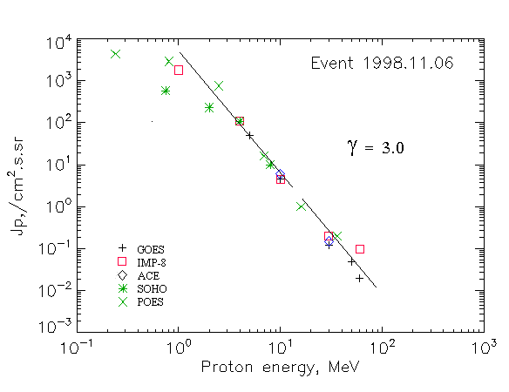

Integral fluxes of protons for the event of 1998 November 06

S/c, instrument | Eр, MeV | To | Tmax | Jmax,  /cm².s.sr | Dura-tion | Comments
GOES-10
EPS | >5 | 03^{h} | 12^{h} | 50.5 | 1.5d
EPS | >10 | 03^{h} | 12^{h} | 4.6 | 1.5d
EPS | >30 | 03^{h} | 12^{h} | 0.12 | 1.5d
EPS | >50 | 03^{h} | 11^{h} | 0.05 | 1.5d
EPS | >60 | 03^{h} | 11^{h} | 0.02 | 1.5d
EPS | >100 | - | - | - | -
POES-15
MEPED | >0.24 | - | 12^{h} | 4360 | 1.5d
MEPED | >0.8 | - | 12^{h} | 2890 | 1.5d
MEPED | >2.5 | - | 12^{h} | 760 | 1.5d
MEPED | >6.9 | - | 12^{h} | 16 | 1.5d
MEPED | >16 | - | 12^{h} | 1 | 1.5d
MEPED | >36 | - | 12^{h} | 0.2 | 1.5d
MEPED | >70 | - | - | - | -
MEPED | >140 | - | - | -. | -
IMP-8
CPME | >1 | 01^{h} | 12^{h} | 1790 | 1.5d
CPME | >4 | 01^{h} | 12^{h} | 110 | 1.5d
CPME | >10 | 01^{h} | 12^{h} | 4.5 | 1.5d
CPME | >30 | 01^{h} | 12^{h} | 0.2 | 1.5d
CPME | >60 | 01^{h} | 12^{h} | 0.1 | -
ACE
SIS | >10 | 07^{h} | 10^{h} | 6 | 1.5d
SIS | >30 | 07^{h} | 08^{h} | 0.15 | 1.5d
SOHO
EPHIN (INT) | >50 | - | 07^{h} | The forbush effect | -
Differential fluxes of protons for the event of 1998 November 06

S/c, instruments | ∆Е, MeV | To | Tmax | Jmax.  /cm².s.sr.MeV | Dura-tion | Comments
 |  |  | Protons
IMP-8
CPME | 1-2 | 01^{h} | 12^{h} | 754 | 1.5d
CPME | 2-4.6 | 01^{h} | 12^{h} | 173 | 1.5d
CPME | 4.6-15 | 01^{h} | 12^{h} | 6.7 | 1.5d
CPME | 15-25 | 01^{h} | 12^{h} | 0.05 | 1.5d
CPME | 25-48 | - | - | - | -
CPME | 48-96 | - | - | - | -
CPME | 96-145 | - | - | - | -
CPME | 145-440 | - | - | - | -
SOHO
LION | 0.75-2 | 02^{h} | 17^{h} | 200 | 2d
LION | 2-6 | 01^{h} | 17^{h} | 30.2 | 2d
EPHIN | 4-8 | 00^{h} | 16^{h} | 24.8 | 1.5d
EPHIN | 8-25 | 00^{h} | 12^{h} | 0.58 | 1.5d
EPHIN | 25-41 | - | - | - | -
EPHIN | 41-53 | - “ - | - “ - | - “ - | - “ -

References
No information on publications, excepting for:
http://www.swpc.noaa.gov/ftpdir/indices/SPE.txt

