Event 1999.01.22 – (1999-022)

Particle event: To(Ep>10 MeV) – 22d02^{h}
Tmax₁(Ep>10 MeV) – 22d16^{h}, Jmax₁ (Ep>10 MeV) – 3 /cm².s.sr
Tmax₂(Ep>10 MeV) – 23d14^{h}, Jmax₂ (Ep>10 MeV) – 5 /cm².s.sr
Duration of the event – 4 days
Energy of the SCR and 0.1 GCR fluxes balance – Eb(max₁) = 85 MeV
Eb(max₂) = 85 MeV

Sources: source unknown
Ø solar flare 22d17^{h}05^{m}, M1.4/SF, N19W44, АR8440
Ø X-ray burst 1-8 Ǻ: onset – 22d17^{h}05^{m}, max – 22d17^{h}24^{m}, Ф = 0.015 J/m²
CME: gap

Particle fluxes and associated phenomena

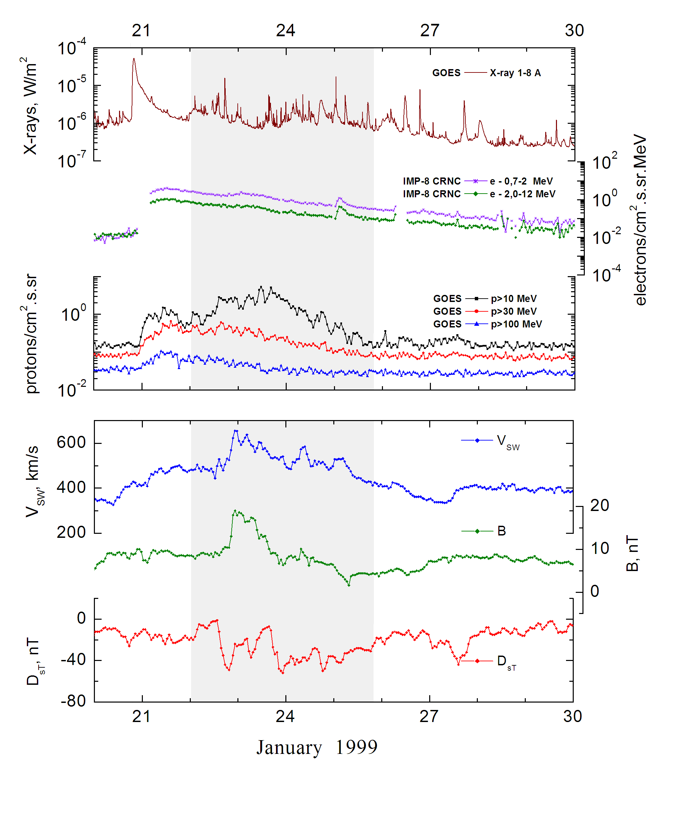
Integral time-of-maximum proton spectrum 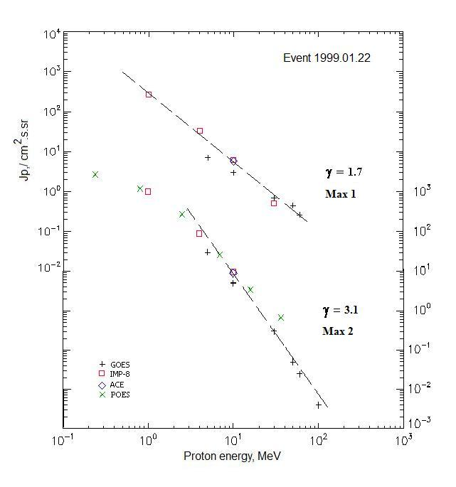

Integral fluxes of protons for the event of 1999 January 22

S/c, instruments | Eр, MeV | To | Tmax | Jmax,  /cm².s.sr | Dura-tion | Comments
GOES-10
EPS | >5 | 03^{h} | 16^{h}/23d14^{h} | 7/30 | 4d
EPS | >10 | 03^{h} | 16^{h}/23d14^{h} | 3/5 | 4d
EPS | >30 | 03^{h} | 16^{h}/23d14^{h} | 0.7/0.3 | 4d
EPS | >50 | - | 16^{h}/23d12^{h} | 0. 45/0.05 | 4d
EPS | >60 | - | 16^{h}/23d12^{h} | 0.26/0.025 | -
EPS | >100 | - | - /23d12^{h} | - /0.004 | -
POES-15
MEPED | >0.24 | 03^{h} | 23d12^{h} | 2820 | 4d
MEPED | >0.8 | 03^{h} | 23d12^{h} | 1220 | 4d
MEPED | >2.5 | 03^{h} | 23d12^{h} | 290 | 4d
MEPED | >6.9 | 03^{h} | 23d12^{h} | 40 | 4d
MEPED | >16 | 03^{h} | 23d12^{h} | 3.43 | 4d
MEPED | >36 | 03^{h} | 23d12^{h} | 0.67 | 4d
MEPED | >70 | - | - | - | -
MEPED | >140 | - | - | - | -
IMP-8
CPME | >1 | 02^{h} | 23^{h}/23d12^{h} | 270/1030 | 6d
CPME | >4 | 02^{h} | 23^{h}/23d12^{h} | 33/92 | 4d
CPME | >10 | 02^{h} | 23^{h}/23d12^{h} | 6.1/9.5 | 4d
CPME | >30 | 02^{h} | 23^{h}/23d12^{h} | 0.5/ - | -
CPME | >60 | - | - / - | - / - | -
ACE
SIS | >10 | 02^{h} | 23^{h}/23d11^{h} | 5.7/9 | 3d
SIS | >30 | - | - / - | - / - | -

Differential fluxes of protons for the event of 1999 January 22

S/c, instruments | ∆Е, MeV | To | Tmax | Jmax  /cm².s.sr.MeV | Dura-tion) | Comments
IMP-8
CPME | 1-2 | 02^{h} | 22d23^{h}/23d12^{h} | 160/610 | 10d
CPME | 2-4.6 | 02^{h} | 22d23^{h}/23d12^{h} | 32.5/120 | 9d
CPME | 4.6-15 | 02^{h} | 22d23^{h}/23d12^{h} | 2.15/6.35 | 8d
CPME | 15-25 | 02^{h} | 22d23^{h}/23d12^{h} | 0.2/0.23 | 6d
CPME | 25-48 | 02^{h} | 22d23^{h}/23d12^{h} | 0.02/0.913 | 4d
CPME | 48-96 | 02^{h} | 22d23^{h}/23d12^{h} | 0.003//0.002 | 2d
CPME | 96-145 | - | - | - | -
CPME | 145-440 | - | - | - | -
SOHO |  | Data | absent

References
No information on publications, excepting for:
http://www.swpc.noaa.gov/ftpdir/indices/SPE.txt

