Event 1999.04.24 – (1999-114)

Particle event: To(Ep>10 MeV) – 24d15^{h}
Tmax₁(Ep>10 MeV) – 24d21^{h}, Jmax₁(Ep>10 MeV) – 3.7 /cm².s.sr
Tmax₂(Ep>10 MeV) – 25d06^{h}, Jmax₁(Ep>10 MeV) – 4.3 /cm².s.sr
Duration of the event – 2 days
Energy of the SCR and 0.1 GCR fluxes balance – Eb(max₁) = 85 MeV
– Eb(max₂) = 210 MeV

Sources: □ back side solar flare event <13^{h}31^{m}, N22W90, АR8517 3 days behind W limb
CME:24d13^{h}31^{m}, V = 1495 km/s, Δφ = 360º, dA= 321º

Particle fluxes and associated phenomena
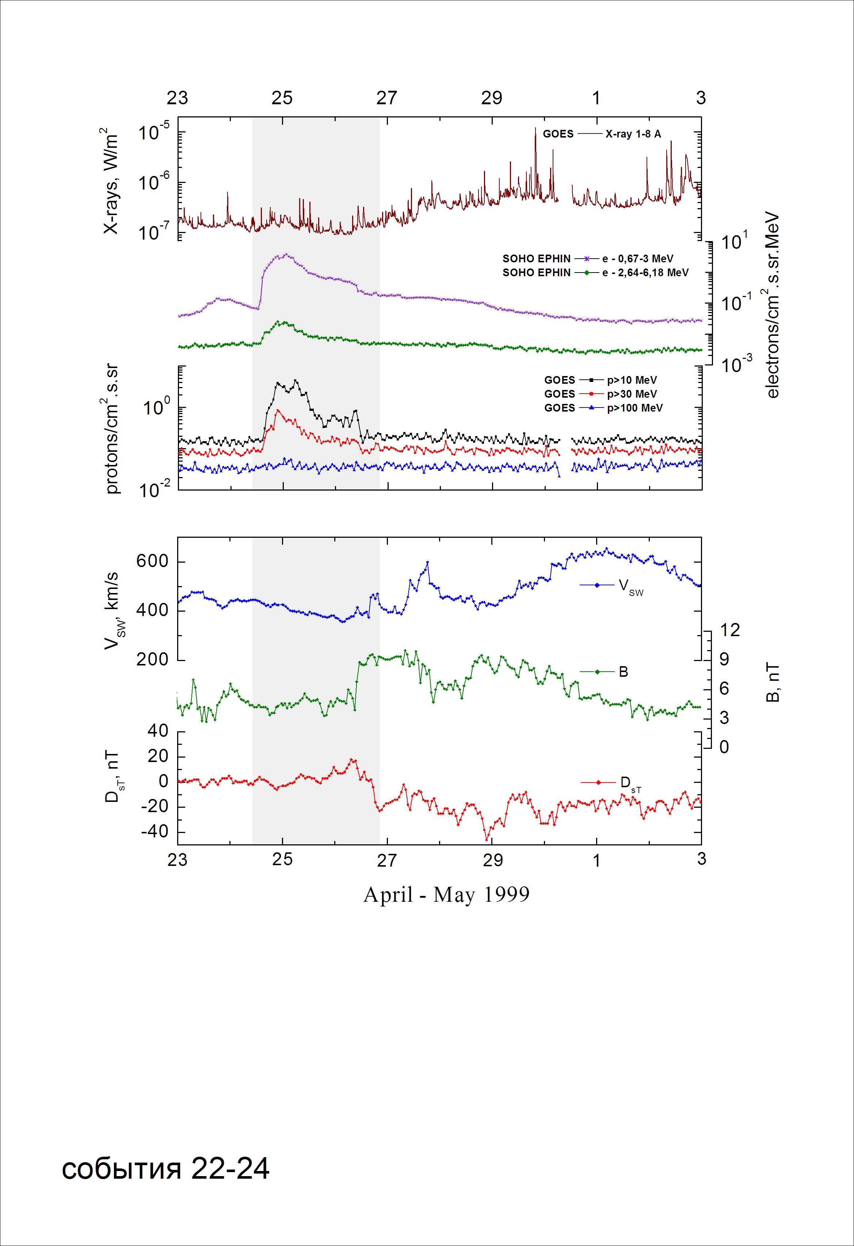

Integral time-of-maximum proton spectrum
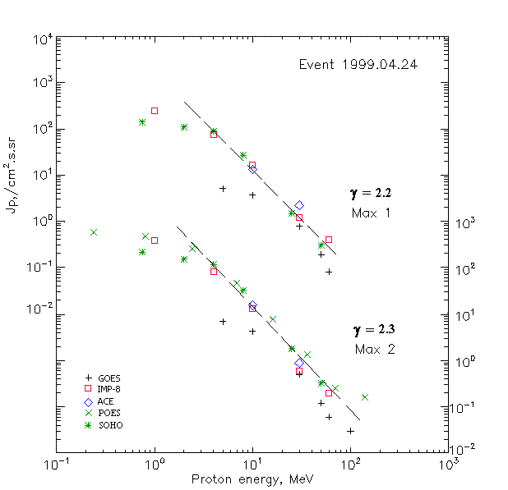

Integral fluxes of protons for the event of 1999 April 24

S/c, instruments | Eр, MeV | To | Tmax | Jmax,  /cm².s.sr | Dura-tion | Comments
GOES-10
EPS | >5 | 15^{h} | 21 ^{h} /25d06 ^{h} | 5.1/7.0 | 2d
EPS | >10 | 15^{h} | 21 ^{h} /25d06 ^{h} | 3.7/4.3 | 2d
EPS | >30 | 15^{h} | 21 ^{h}/ 25d05 ^{h} | 0.77/ 0.5 | 2d
EPS | >50 | 15^{h} | 21 ^{h}/ 25d05 ^{h} | 0.19/ 0.12 | 1d
EPS | >60 | 15^{h} | 22 ^{h}/ 25d04 ^{h} | 0.08/ 0.06 | 1d
EPS | >100 | 15^{h} | - /25d00 ^{h} | - /0.03 | 1d
POES-15
MEPED | >0.24 | - | - /25d01 ^{h} | - /582 | -
MEPED | >0.8 | - | - /25d01 ^{h} | - /480 | -
MEPED | >2.5 | - | - /25d01 ^{h} | - /296 | -
MEPED | >6.9 | - | - /25d01 ^{h} | - /70 | -
MEPED | >16 | - | - /25d01 ^{h} | - /7.83 | -
MEPED | >36 | - | - /25d01 ^{h} | - /1.36 | -
MEPED | >70 | - | - /25d01 ^{h} | - /0.25 | -
MEPED | >140 | - | - /25d01 ^{h} | - /0.16 | -
IMP-8
CPME | >1 | 15^{h} | 23^{h}/25d04^{h} | 250/410 | 2.5d
CPME | >4 | 15^{h} | 23^{h}/25d05^{h} | 75/85 | 2.5d
CPME | >10 | 15^{h} | 22^{h}/25d05^{h} | 16.7/13.6 | 2.5d
CPME | >30 | 15^{h} | <22^{h}/25d05^{h} | 1.2/0.6 | 2.5d
CPME | >60 | 16^{h} | <22^{h}/25d05^{h} | 0.4/0.2 | 2.5d
ACE
SIS | >10 | 15^{h} | 21^{h}/25d02^{h} | 13.3/16 | 1.5d
SIS | >30 | 15^{h} | 21^{h}/25d02^{h} | 1.1/0.9 | 1d
SOHO
EPHIN (INT) | >50 | 14^{h} | 17^{h}/23^{h} | 0.3/0.33 | ∼0.5d

Differential fluxes of protons for the event of 1999 April 24

S/c, instruments | ∆Е, MeV | To | Tmax | Jmax  /cm².s.sr.MeV | Dura-tion | Comments
IMP-8
CPME | 1-2 | - | - /25d04^{h} | - /179 | ∼2,8d
CPME | 2-4.6 | - | - /25d04^{h} | - /64 | ∼2,8d
CPME | 4.6-15 | - | - /25d04^{h} | - /6,1 | ∼2,8d
CPME | 15-25 | - | - /25d04^{h} | - /0,5 | ∼2,5d
CPME | 25-48 | - | - /25d04^{h} | - /0,03 | ∼2d
CPME | 48-96 | - | - /25d04^{h} | - /0,01 | ∼2d
CPME | 96-145 | - | - / - | - / - | -
CPME | 145-440 | - | - / - | - / - | -
SOHO
LION | 0,75-2 | 16^{h} | 22^{h}/25d02^{h} | 17/37 | ∼2d
LION | 2-6 | 16^{h} | 22^{h}/25d02^{h} | 5,1/9,3 | ∼2d
EPHIN | 4-8 | 14^{h} | 22^{h}/25d02^{h} | 15.5/22 | ∼2.5d
EPHIN | 8-25 | 14^{h} | 21^{h}/25d02^{h} | 1.5/1.9 | ∼2.5d
EPHIN | 25-41 | 14^{h} | 21^{h}/25d02^{h} | 0.05/0.04 | ∼2.5d
EPHIN | 41-53 | - “ - | - “ - | - “ - | - “ -

References
No information on publications, excepting for:
http://www.swpc.noaa.gov/ftpdir/indices/SPE.txt

