Event 1999.05.09 – (1999-129)

Particle event: To(Ep>10 MeV) – 09d19^{h}
Tmax(Ep>10 MeV) – 09d21^{h}, Jmax (Ep>10 MeV) – 1.2 /cm².s.sr *)
Duration of the event – 1 day
Energy of the SCR and 0.1 GCR fluxes balance – Eb = 75 MeV
*) The data from IMP-8

Sources:  solar flare 09d17^{h}53^{m}, M7.6/ …, N23W90, АR8526 one day behind W limb;
Main X-ray burst 1-8 Ǻ: onset – 09d17^{h}53^{m}, max – 09d18^{h}07^{m}, Ф = 0.061 J/m²
CME: 09d18^{h}27^{m}, V = 0615 km/s, Δφ = 172º, dA = 316º

Particle fluxes and associated phenomena
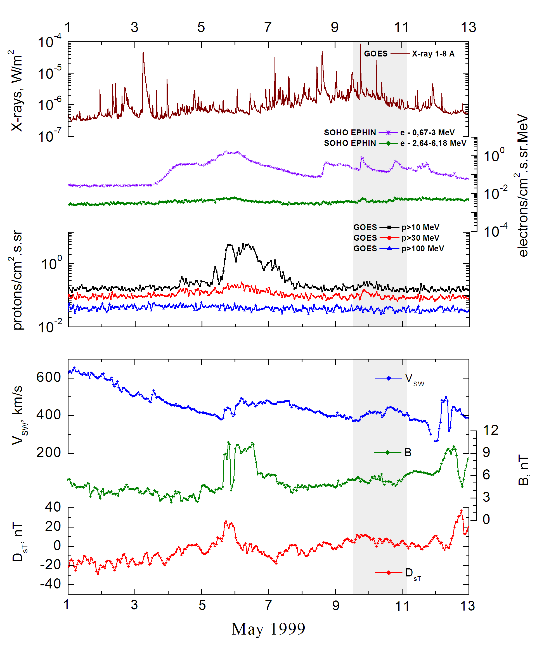

Integral time-of-maximum proton spectrum
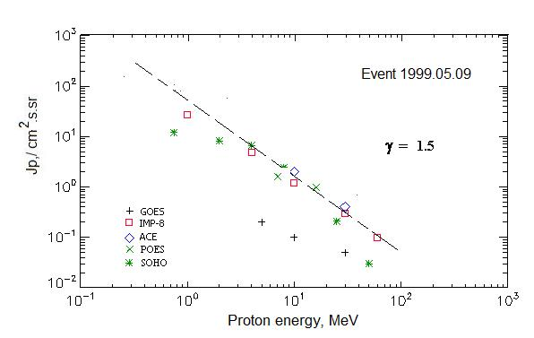

Integral fluxes of protons for the event of 1999 May 09

S/c, instruments | Eр, MeV | To | Tmax | Jmax,  /cm².s.sr | Dura-tion | Comments
GOES-10
EPS | >5 | - | 22^{h} | 0.2 | 1d
EPS | >10 | - | 22^{h} | 0.1 | 1d
EPS | >30 | - | 21^{h} | 0.05 | 0.5d
EPS | >50 | - | - | - | -
EPS | >60 | - | - | - | -
EPS | >100 | - | - | - | -
POES-15
MEPED | >0.24 | - | 23^{h} | 96 | -
MEPED | >0.8 | - | 23^{h} | 56 | -
MEPED | >2.5 | - | 23^{h} | 32 | -
MEPED | >6.9 | - | 23^{h} | 8 | -
MEPED | >16 | - | 23^{h} | 0.99 | -
MEPED | >36 | - | 23^{h} | 0.61 | -
MEPED | >70 | - | 23^{h} | 0.2 | -
MEPED | >140 | - | 23^{h} | 0.22 | -
IMP-8
CPME | >1 | 21^{h} | 23^{h} | 27.4 | 4d
CPME | > 4 | 19^{h} | 22^{h} | 4.8 | 1d
CPME | >10 | 19^{h} | 21^{h} | 1.2 | 1d
CPME | >30 | 19^{h} | 20^{h} | 0.3 | 1d
CPME | >60 | 19^{h} | 20^{h} | 0.1 | 1d
ACE
SIS | >10 | 18^{h} | 21^{h} | 2 | 1d
SIS | >30 | 18^{h} | 22^{h} | 0.4 | 1d
SOHO
EPHIN (INT) | >50 | 18^{h} | 20^{h} | 0.03 | 0.5d

Differential fluxes of protons for the event of 1999 May 09

S/c, instruments | ∆Е, MeV | To | Tmax | Jmax  /cm².s.sr.MeV | Dura-tion | Comments
IMP-8
CPME | 1-2 | 21^{h} | 23^{h} | 15.2 | 3d
CPME | 2-4.6 | 21^{h} | 23^{h} | 3.7 | 2d
CPME | 4.6-15 | 20^{h} | 22^{h} | 0,33 | 2d
CPME | 15-25 | <20^{h} | 22^{h} | 0,04 | 1d
CPME | 25-48 | <20^{h} | 21^{h} | 0,009 | 1d
CPME | 48-96 | - | - | - | -
CPME | 96-145 | - | - | - | -
CPME | 145-440 | - | - | - | -
SOHO
LION | 0,75-2 | 22^{h} | 10d02^{h} | 2.2 | 3d
LION | 2-6 | 21^{h} | 23^{h} | 0.387 | 3d
EPHIN | 4-8 | 20^{h} | 22^{h} | 1.05 | 5d
EPHIN | 8-25 | 19^{h} | 21^{h} | 0.13 | 3d
EPHIN | 25-41 | 18^{h} | 20^{h} | 0.009 | 2d
EPHIN | 41-53 | - “ - | - “ - | - “ - | - “ -

References
No information on publications, excepting for:
http://www.swpc.noaa.gov/ftpdir/indices/SPE.txt

