Event 1999.05.27 – (1999-147)

Particle event: To(Ep>10 MeV) – 27d12^{h}
Tmax(Ep>10 MeV) – 27d13^{h}, Jmax (Ep>10 MeV) – 2.75 /cm².s.sr
Duration of the event – 1.5 days
Energy of the SCR and 0.1 GCR fluxes balance – Eb = 275 MeV

Sources: □ back side flare event
○ solar flare 26d19^{h}15^{m}, M1.2/2N, N17E46, АR8552
CME: 27d11^{h}06^{m}, V = 1691 km/s, Δφ = 360º, dA = 341º

Particle fluxes and associated phenomena
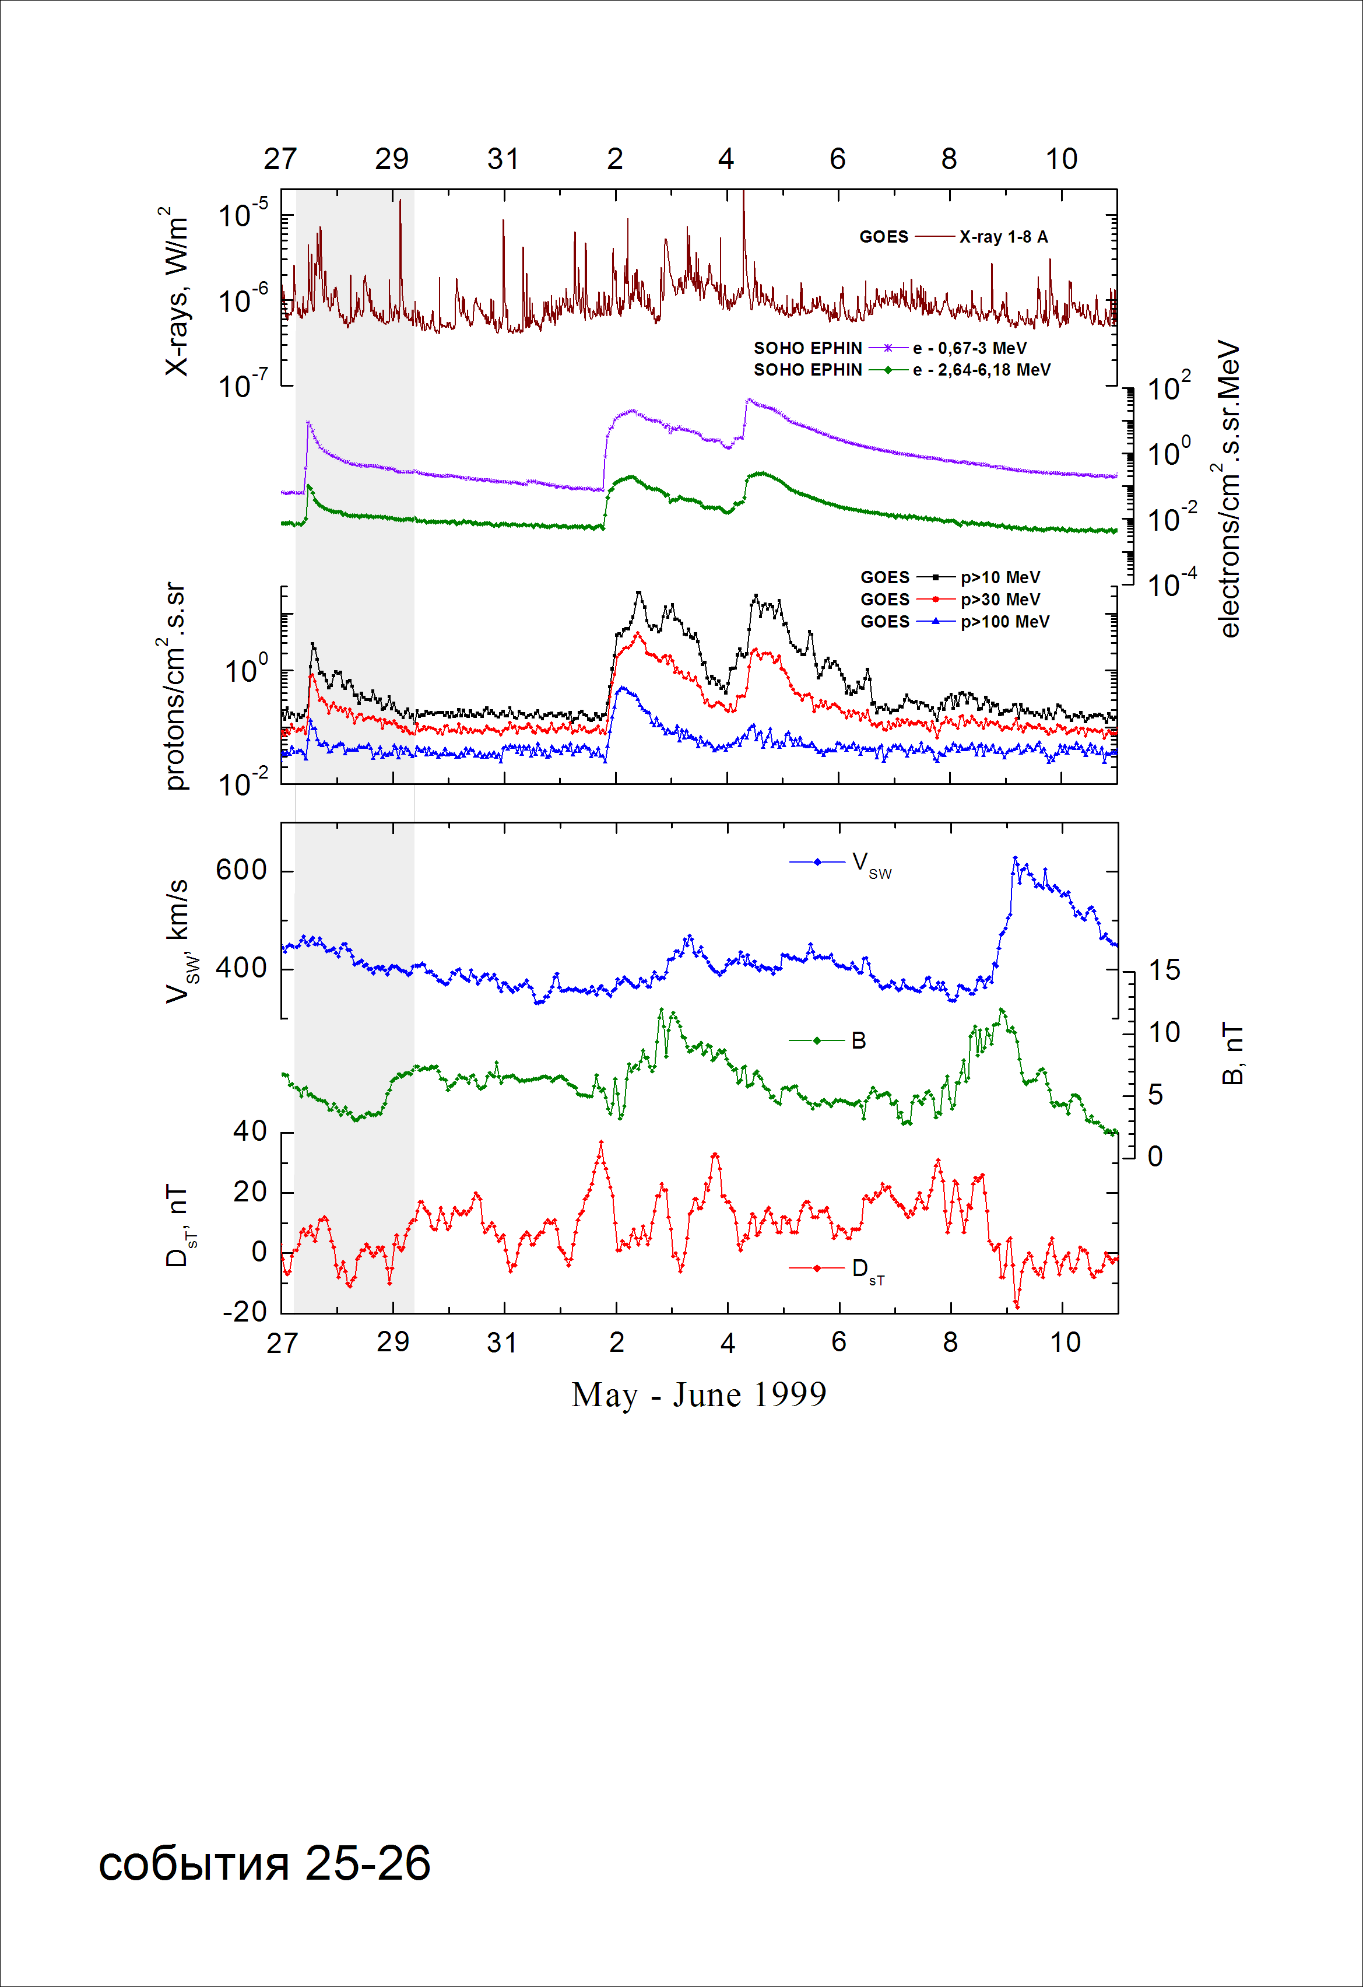

Integral time-of-maximum proton spectrum
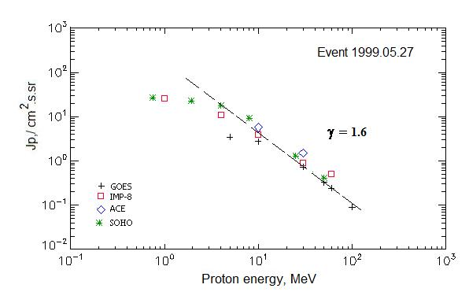

Integral fluxes of protons for the event of 1999 May 27

S/c,  instruments | Eр, MeV | To | Tmax | Jmax,  /cm².s.sr | Dura-tion | Comments
GOES-10
EPS | >5 | 12^{h} | 13^{h} | 3.44 | 1.5d
EPS | >10 | 12^{h} | 13^{h} | 2.75 | 1.5d
EPS | >30 | 12^{h} | 13^{h} | 0.73 | 1.5d
EPS | >50 | 12^{h} | 12^{h} | 0.33 | 1d
EPS | >60 | 12^{h} | 12^{h} | 0.24 | 1d
EPS | >100 | - | 12^{h} | 0.09 | 1d
IMP-8
CPME | >1 | 12^{h} | 15^{h} | 25.6 | 2d
CPME | >4 | 12^{h} | 15^{h} | 11 | 2d
CPME | >10 | 12^{h} | 14^{h} | 3.9 | 1.5d
CPME | >30 | 11^{h} | 13^{h} | 0.9 | 1d
CPME | >60 | 11^{h} | 12^{h} | 0.5 | 1d
ACE
SIS | >10 | 11^{h} | 14^{h} | 5.7 | 1d
SIS | >30 | 11^{h} | 13^{h} | 1.5 | 1d
SOHO
EPHIN (INT) | >50 | 11^{h} | 13^{h} | 0.41 | 1d
Differential fluxes of protons for the event of 1999 May 27

S/c, instruments | ∆Е, MeV | To | Tmax | Jmax  /cm².s.sr.MeV | Dura-tion | Comments
IMP-8
CPME | 1-2 | 14^{h} | 19^{h} | 14.8 | 1.5d
CPME | 2-4.6 | 13^{h} | 19^{h} | 5.7 | 1.5d
CPME | 4.6-15 | 13^{h} | 15^{h} | 0.7 | 1.5d
CPME | 15-25 | 13^{h} | 14^{h} | 0.17 | 1.5d
CPME | 25-48 | 13^{h} | 13^{h} | 0.025 | 1d
CPME | 48-96 | 12^{h} | 12^{h} | 0.006 | 1d
CPME | 96-145 | 12^{h} | 12^{h} | - | 1d
CPME | 145-440 | 12^{h} | 12^{h} | 0.001 | 1d
SOHO
LION | 0,75-2 | 16^{h} | 14^{h} | 2.1 | 1.5d
LION | 2-6 | 16^{h} | 15^{h} | 0.47 | 1.5d
EPHIN | 4-8 | 11^{h} | 14^{h} | 2.1 | 1.5d
EPHIN | 8-25 | 11^{h} | 14^{h} | 0.47 | 1.5d
EPHIN | 25-41 | 11^{h} | 14^{h} | 0.04 | 1.5d
EPHIN | 41-53 | - “ - | - “ - | - “ - | - “ -

References
Slocum P.L., E.C. Stone, R.A. Leske, E.R., et.al., 2003.

