Event 1999.06.01 – (1999-152)

Particle event: To(Ep>10 MeV) – 01d20^{h}
Tmax₁(Ep>10 MeV) – 02d09^{h}, Jmax₁(Ep>10 MeV) – 23 /cm².s.sr
Tmax₂(Ep>10 MeV) – 02d21^{h}, Jmax₂(Ep>10 MeV) – 13 /cm².s.sr
Duration of the event – 2 days
Energy of the SCR and 0.1 GCR fluxes balance – Eb(max₁) = 350 MeV
– Eb(max₂) = 240 MeV
Sources: □ back side solar flare 01d18^{h}53^{m}, C1.2/..., N25W90, АR ….
Main X-ray burst 1-8 Ǻ: onset – 01d18^{h} 53^{m}, max – 01d19^{h}04^{m}, Ф = 0.0027 J/m²
CME: 01d19^{h}37^{m}, V = 1772 km/s, Δφ = 360º; dA=359º

Particle fluxes and associated phenomena
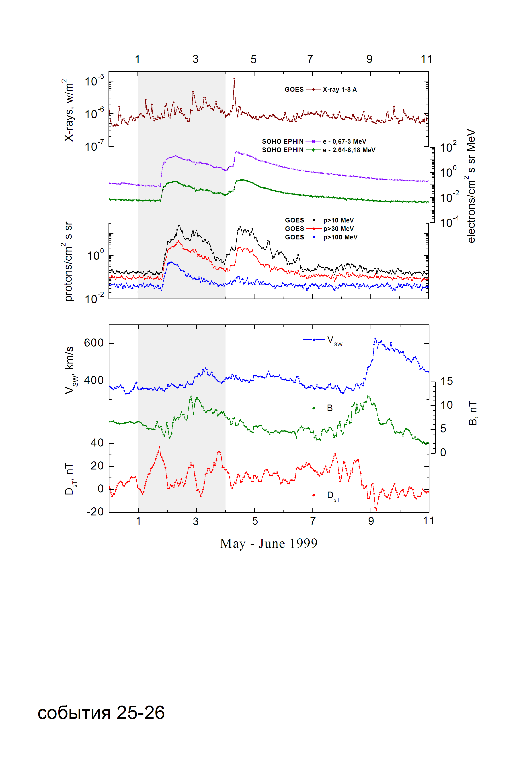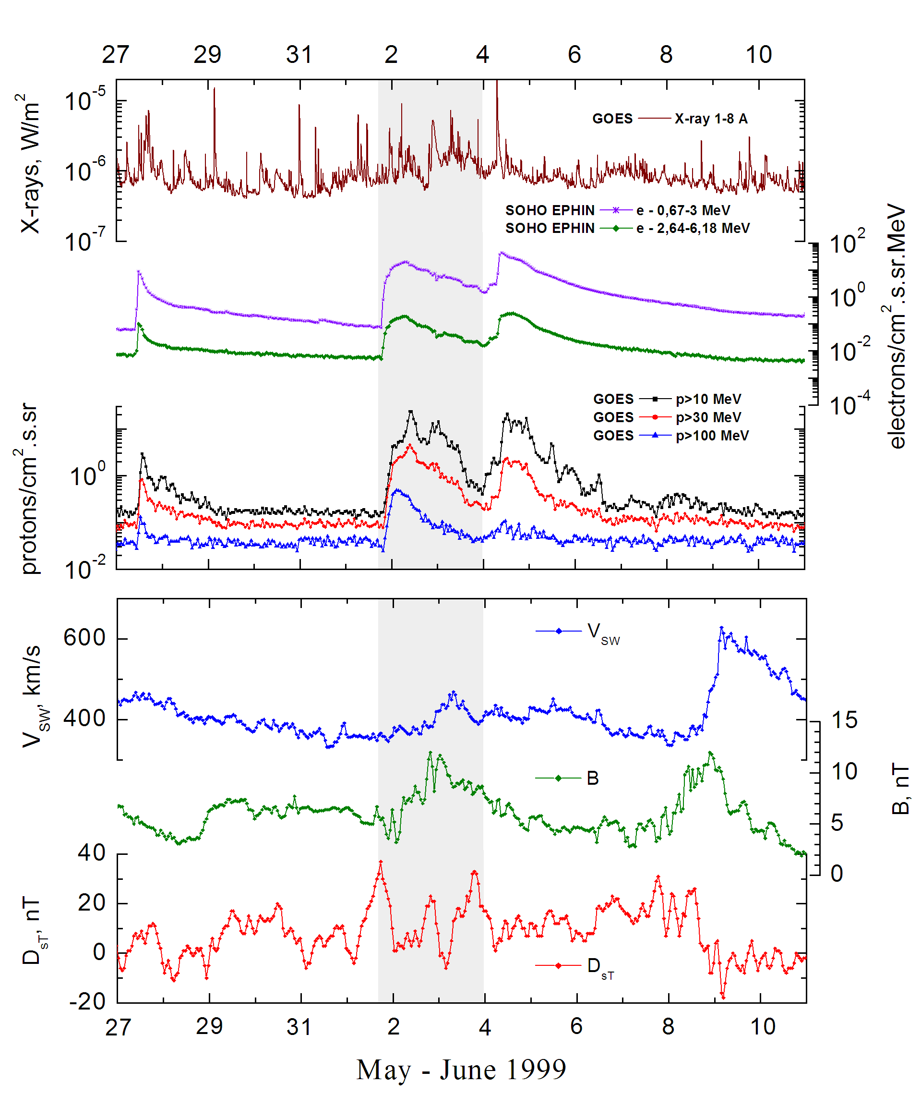
Integral time-of-maximum proton spectrum
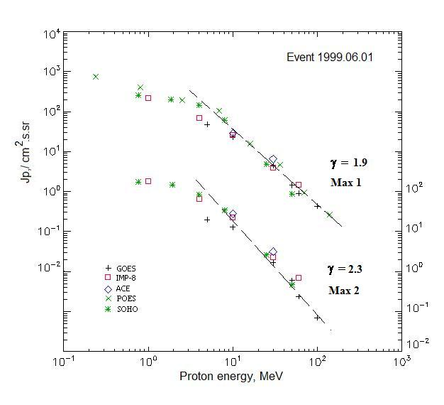

Integral fluxes of protons for the event of 1999 June 01

S/c, instruments | Eр, MeV | To | Tmax | Jmax,  /cm².s.sr | Dura-tion | Comments
GOES-10
EPS | >5 | 20^{h} | 02d10^{h}/02d21^{h} | 47/20.1 | 2d
EPS | >10 | 20^{h} | 02d09^{h}/02d21^{h} | 23/13 | 2d
EPS | >30 | 20^{h} | 02d09^{h}/02d21^{h} | 4.4/1.7 | 2d
EPS | >50 | 20^{h} | 02d09^{h}/02d21^{h} | 1.42/0.6 | 2d
EPS | >60 | 20^{h} | 02d05^{h}/02d20^{h} | 0.90/0.24 | 2d
EPS | >100 | 20^{h} | 02d03^{h}/02d20^{h} | 0.43/0.07 | 2d
POES-15
MEPED | >0.24 | - | 02d08^{h}/ - | 755/ - | 2d
MEPED | >0.8 | - | 02d08^{h}/ - | 403/ - | 2d
MEPED | >2.5 | - | 02d08^{h}/ - | 192/ - | 2d
MEPED | >6.9 | - | 02d08^{h}/ - | 106/ - | 2d
MEPED | >16 | - | 02d08^{h}/ - | 16/ - | 2d
MEPED | >36 | - | 02d08^{h}/ - | 4.65/ - | 2d
MEPED | >70 | - | 02d08^{h}/ - | 0.93/ - | 2d
MEPED | >140 | - | 02d08^{h}/ - | 0.26/ - | 2d
IMP-8
CPME | >1 | 21^{h} | 02d09^{h}/02d19^{h} | 215/188 | 2 d
CPME | >4 | 21^{h} | 02d09^{h}/02d19^{h} | 68/65,4 | 2 d
CPME | >10 | 21^{h} | 02d09^{h}/02d19^{h} | 26/23 | 2 d
CPME | >30 | 21^{h} | 02d08^{h}/02d19^{h} | 3.9/2.3 | 2 d
CPME | >60 | 21^{h} | 02d07^{h}/02d19^{h} | 1.5/0.7 | 2 d
ACE
SIS | >10 | 21^{h} | 02d08^{h}/02d18^{h} | 29/28.3 | 2 d
SIS | >30 | 21^{h} | 02d07^{h}/02d18^{h} | 6.5/3.2 | 2 d
SOHO
EPHIN (INT) | >50 | 20^{h} | 02d07^{h}/02d19^{h} | 0.85/0.47 | -

Differential fluxes of protons for the event of 1999 June 01

S/c, instruments | ∆Е, MeV | To | Tmax | Jmax  /cm².s.sr.MeV | Dura-tion | Comments
IMP-8
CPME | 1-2 | 02d01^{h} | 02d09^{h}/02d19^{h} | 80.2/66 | 2d
CPME | 2-4.6 | 22^{h} | 02d09^{h}/02d19^{h} | 30/25.6 | 2d
CPME | 4.6-15 | 21^{h} | 02d09^{h}/02d19^{h} | 4.0/4.1 | 2d
CPME | 15-25 | 21^{h} | 02d09^{h}/02d19^{h} | 1.2/1.05 | 2d
CPME | 25-48 | 21^{h} | 02d08^{h}/02d19^{h} | 0.14/0.095 | 2d
CPME | 48-96 | 20^{h} | 02d08^{h}/02d19^{h} | 0.020/0.01 | 2d
CPME | 96-145 | - / - | - / - | - / - | -
CPME | 145-440 | - / - | - / - | - / - | -
SOHO
LION | 0,75-2 | 21^{h} | 02d07^{h}/02d19^{h} | 46.6/21.6 | 2d
LION | 2-6 | 21^{h} | 02d07^{h}/02d19^{h} | 9.6/4.9 | 2d
EPHIN | 4-8 | 21^{h} | 02d07^{h}/02d19^{h} | 20.7/12.1 | 2d
EPHIN | 8-25 | 21^{h} | 02d07^{h}/02d19^{h} | 3.3/1.9 | 2d
EPHIN | 25-41 | 20^{h} | 02d07^{h}/02d19^{h} | 0.17/0.1 | 2d
EPHIN | 41-53 | - “ - | - “ - | - “ - | - “ -

References:
No information on publications, excepting for:
http://www.swpc.noaa.gov/ftpdir/indices/SPE.txt

