Event 1999.06.25 – (1999-176)

Particle event: To(Ep>10 MeV) – 25d10^{h}
Tmax(Ep>10 MeV) – 26d12^{h}, Jmax(Ep>10 MeV) – 1.7 /cm².s.sr *)
Duration of the event – 2 days
Energy of the SCR and 0.1 GCR fluxes balance – Eb = 40 MeV
*) The data from IMP-8

Sources: ○ solar flare 24d12^{h}04^{m}, C4.1/1F, N29W13, AR8595
 solar flare 26d05^{h}08^{m}, M2.3/2B, N24E02, АR8598
Main X-ray burst 1-8 Ǻ: onset – 26d05^{h}08^{m}, max – 26d05^{h}12^{m}, Ф = 0.004 J/m²
CME: 24d13^{h}31^{m}, V = 0975 km/s, Δφ = 360º, dA = 335º
▲SC 26d03^{h}25 ^{m}, 26d20^{h}16 ^{m}

Particle fluxes and associated phenomena
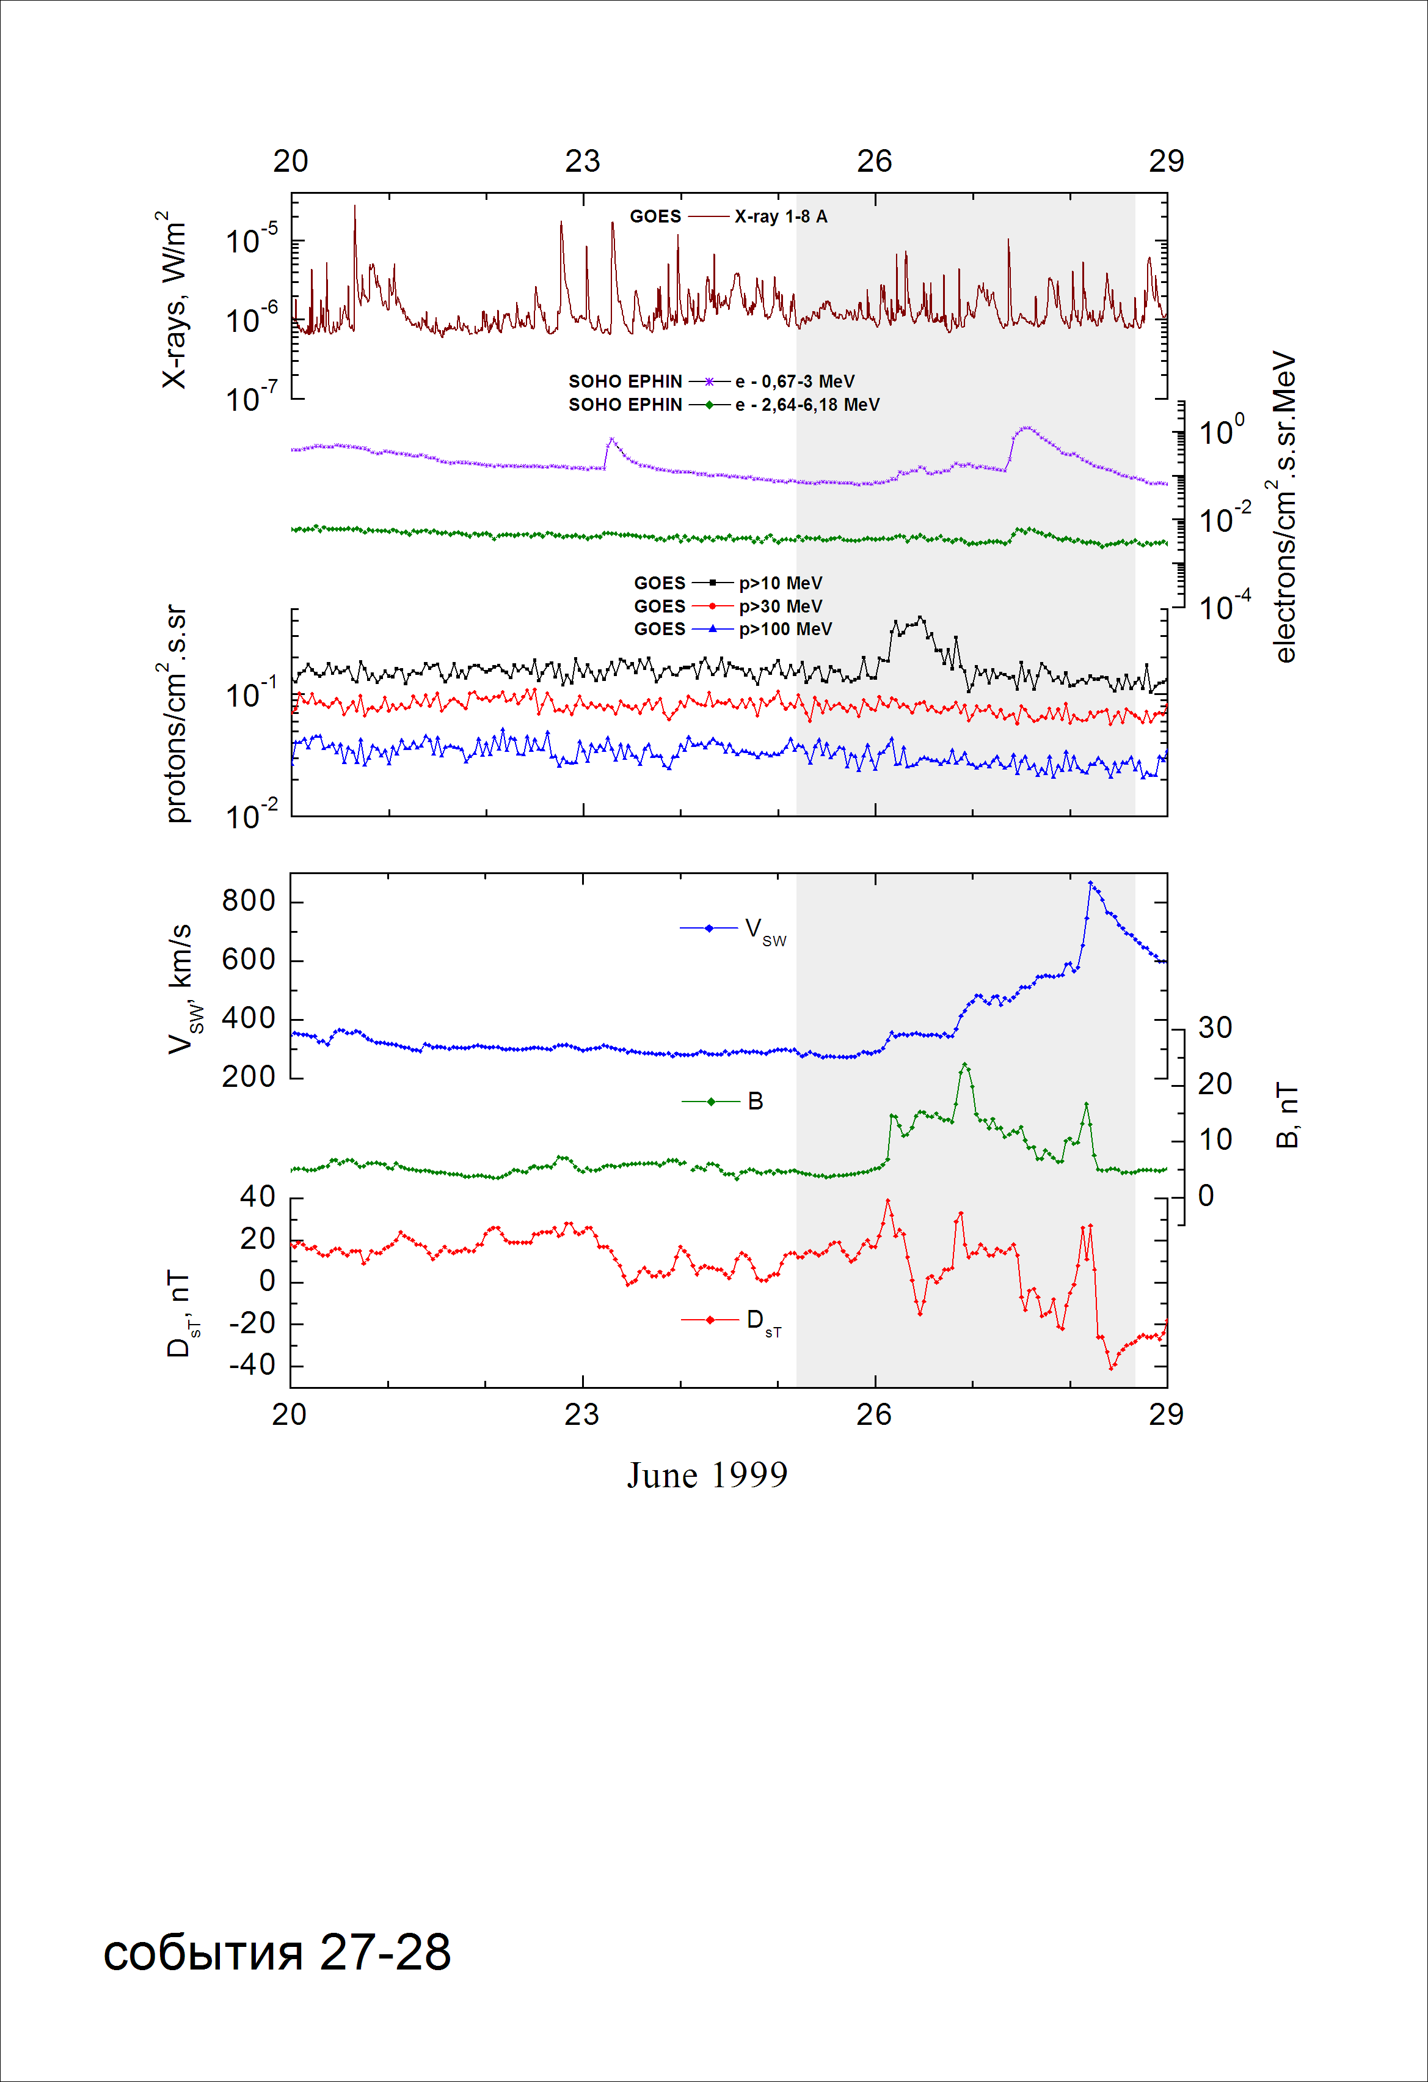

Integral time-of-maximum proton spectrum
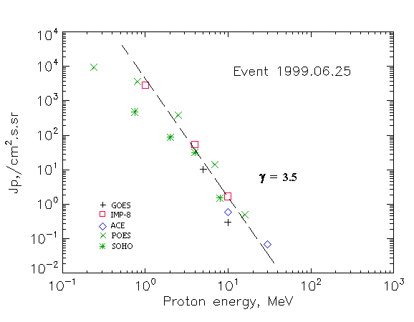

Integral fluxes of protons for the event of 1999 June 25

S/c, instruments | Eр, MeV | To | Tmax | Jmax,  /cm².s.sr | Dura  -tion | Comments
GOES-10
EPS | >5 | 20 ^{h} | 26d12 ^{h} | 10.3 | 1d
EPS | >10 | 21 ^{h} | 26d11 ^{h} | 0.3 | 1d
EPS | >30 | - | 26d12 ^{h} | 0.003 | -
EPS | >50 | - | - | - | -
EPS | >60 | - | - | - | -
EPS | >100 | - | - | - | -
POES-15
MEPED | >0.24 | - | 26d10^{h} | 9310 | -
MEPED | >0.8 | - | 26d10^{h} | 3670 | 2d
MEPED | >2.5 | - | 26d10^{h} | 390 | 2d
MEPED | >6.9 | - | 26d10^{h} | 14 | 2d
MEPED | >16 | - | 26d10^{h} | 0.5 | 2d
MEPED | >36 | - | 26d10^{h} | 0.3 | 2d
MEPED | >70 | - | 26d10^{h} | 0.22 | 2d
MEPED | >140 | - | 26d10^{h} | 0.2 | 2d
IMP-8
CPME | >1 | 8^{h} | 26d12^{h} | 2790 | 2d
CPME | >4 | 10^{h} | 26d12^{h} | 54 | 2d
CPME | >10 | 10^{h} | 26d12^{h} | 1.7 | 2d
CPME | >30 | - | - | - | -
CPME | >60 | - | - | - | -
ACE
SIS | >10 | 8^{h} | 26d10^{h} | 0.6 | 2d
SIS | >30 | - | 26d12^{h} | 0.07 | -
SOHO
EPHIN (INT) | >50 | - | - | - | - | Forbush

Differential fluxes of protons for the event of 1999 June 25

S/c, instruments | ∆Е, MeV | To | Tmax | Jmax  /cm².s.sr.MeV | Dura-tion | Comments
IMP-8
CPME | 1-2 | 09^{h} | 26d12 ^{h} | 2340 | 3d
CPME | 2-4.6 | 08^{h} | 26d12 ^{h} | 226 | 3d
CPME | 4.6-15 | 08^{h} | 26d12 ^{h} | 3.2 | 3d
CPME | 15-25 | - | - | - | -
CPME | 25-48 | - | - | - | -
CPME | 48-96 | - | - | - | -
CPME | 96-145 | - | - | - | -
CPME | 145-440 | - | - | - | -
SOHO
LION | 0,75-2 | 06^{h} | 26d13 ^{h} | 222 | 2d
LION | 2-6 | 06^{h} | 26d13 ^{h} | 18.5 | 2d
EPHIN | 4-8 | 06^{h} | 26d12 ^{h} | 7.6 | 2d
EPHIN | 8-25 | 06^{h} | 26d12 ^{h} | 0.09 | 2d
EPHIN | 25-41 | - | - | - | -
EPHIN | 41-53 | - “ - | - “ - | - “ - | -

References:
No information on publications, excepting for:
http://www.swpc.noaa.gov/ftpdir/indices/SPE.txt

