Solar particle dynamics during magnetic storms of July 23-27, 2004.

S.N. Kuznetsov†, L.L. Lazutin, M.I. Panasyuk, L.I. Starostin, Yu.V. Gotseliuk, (a)
N. Hasebe, K. Sukurai and M. Hareyama (b)

a) Moscow State University, Scobeltsyn Institute for Nuclear Physics, Space Physics Division
Vorob'evy Gory, Moscow119992, Russia
b) Research Institute for Science and Engineering, Waseda University, 3-4-1 Okubo, Shinjuku, Tokyo 169-8555 Japan
lll@srd.sinp.msu.ru

Abstract

It is a case study of a chain of three magnetic storms with a special attention to the particle dynamics based on CORONAS-F and SERVIS-1 low altitude satellite measurements. Solar proton penetration inside the polar cap and inner magnetosphere and dynamics at different phases of the magnetic storms were studied. We found, that solar protons were captured to the inner radiation belt at the recovery phase of the first and the second magnetic storms and additionally accelerated during the last one. No evidence of SC particle injection was found. Enhanced solar proton belt intensity with small pitch angles decreased slowly during satellite orbits for 30 days until the next magnetic storm. Then in 20-30 hours we registered strong precipitation of these protons followed by the trapped proton flux dropout. Intensity decrease was more pronounced at lower altitudes and higher particle energies.

1. Introduction

During magnetic storms usually stable inner proton radiation belt exhibit intensity variations of a short time scale. Bostrem et al. (1970) observed low-energy (1-15 MeV) proton intensity increases and decreases on L=2-4. Mineev et al. (1983) supposed that increase of particle flux is associated with solar cosmic rays (SCR). Slocum et al. (2002) found 11 events when new radiation belts appeared during magnetic storms from 2000 to 2002. Lorenzen et al. (2002) found additional trapping regions of 2-15 MeV protons during strong magnetic storms of 1998 and 2000. Solar origin of this particles follows from the presence of the helium ions.

After the sudden commencement (SC) of the March 24, 1991 magnetic storm, energetic ions and electrons enhancements were registered by CRRES satellite in the inner magnetosphere (Blake et al., 1992). It was explained by the particles resonant acceleration and inward injection by the E-field induced by SC pulse (Li et al., 1993, Pavlov et al., 1993, Hudson et al., 1997). The SC injection became accepted as a main source of the solar cosmic ray trapping into the inner radiation belt.
Alternative model was suggested by Lazutin et al., (2006), when direct trapping of the 1-5 MeV solar protons was registered by CORONAS-F particle detectors during extreme magnetic storms of October 29-31, 2003. They found that when proton cutoff latitude or penetration boundary (PB) started to retreat during magnetic storm recovery phase, low energy protons remain on the closed drift orbits creating new or changing the old inner radiation belts at L=2-4. PB retreat model was supported by analysis of the measurements during two November 2001 magnetic storms (Lazutin et al., 2007).
During moderate magnetic storms of July 2004 energetic proton and electron trapping was registered by particle detectors of the SERVIS-1 satellites (Kodaira et al., 2005). Present paper offers analysis of this event based on the measurements of the energetic protons and electrons by the particle spectrometers on board of two polar satellites CORONAS-F and SERVIS-1, which operates on different altitudes. This allows to found new effects of the SCR dynamics inside the magnetosphere in general and of the trapping process particularly.

2. Observations

CORONAS-F (C-F) particle detector has four proton differential channels (1-5, 14-26, 26-50 and 50-90 MeV). At the altitude of 500 km trapped particles may be seen only over the Brazilian Magnetic anomaly (BMA), and adjacent South-Atlantic region, while on the majority of the trajectories only precipitating particles were recorded. SERVIS-1 (S-1) Light Particle Detectors (LPDs) measured protons and electrons in the energy range from 1.2 to 130 MeV and 0.3 - 10 MeV, respectively. Altitude of 1000 km and inclination of 100° on the solar synchronous orbit allows to register trapping particles more often.
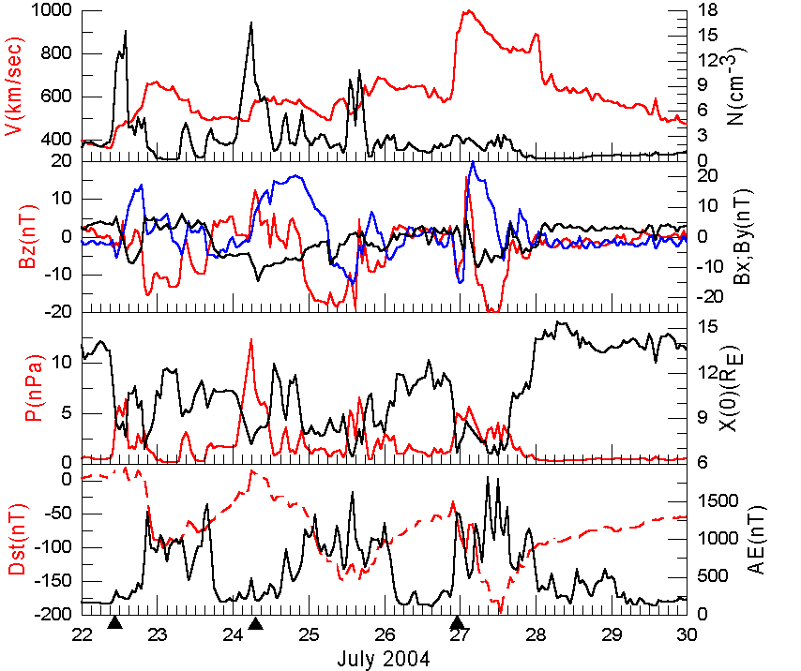

Fig. 1. Solar wind (ACE) and magnetic indexes during July 2004 magnetic storms.

2.1 Event description

Solar wind and magnetic activity indexes are shown by Fig. 1. There were three moderate magnetic storms. During all magnetic storms IMF Bz was negative and auroral activity index was at high level. Table 1 presents characteristic time of the magnetic storms development.

Table 1. Main time-marks of three July 2004 magnetic storms
SC SC | MaMain phase end | Re Recovery phaphase end end | Dst Dst  Ma max, nT
22 07 1036 UT | 22.07 21 UT | 24.07 06 T | 10 100
24 07 0614 UT | 24.07 12 UT – 25.07 10 UT | 26.07 16 UT | 15 150
26 07 2249 UT | 26.07 23 UT – 27.07 14 UT | 30.07 12 UT | 20 200

Solar wind velocity was at moderate level of 500-700 km/s during first two storms and up to 1000 km/s during the third one. Short enhancements of the solar wind pressure were recorded at the main phases of all three storms and associated position of the subsolar magnetosphere boundary approached the Earth to 7-8 Re as calculated by Kuznetsov and Suvorova (1996) method.
Solar cosmic rays, electrons and protons were registered in IMF by ACE and inside the magnetosphere by both S-1 and C-F satellites.

2.2 Penetration boundary definition and dynamics

There are no exact definition of the PB position. One reason comes from the dependence of the cutoff rigidity from the particle energy. More energetic protons penetrate closer to the Earth as shown by Fig. 2a. Also PB position might be defined eider by the background
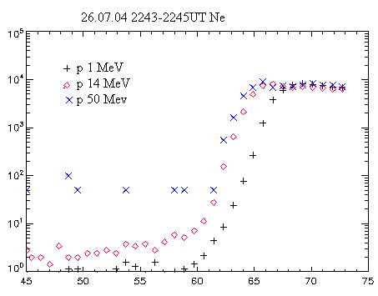
Fig. 2a. Energy dependence of the radial profiles of the solar protons, CORONAS-F satellite.

counting level (PBb) or by last maximum intensity position (PBm), as shown by Fig 2b. Finally, if the PB position overlaps with previously trapped population, then PB boundary can not be found. It was the case for the most of S-1 orbits, the comparison of the S-1 and C-F proton radial profiles shown by Fig. 2b illustrates this statement. Therefore we used C-F to define the PB position and S-1 for the study of the dynamics of trapped radiation.
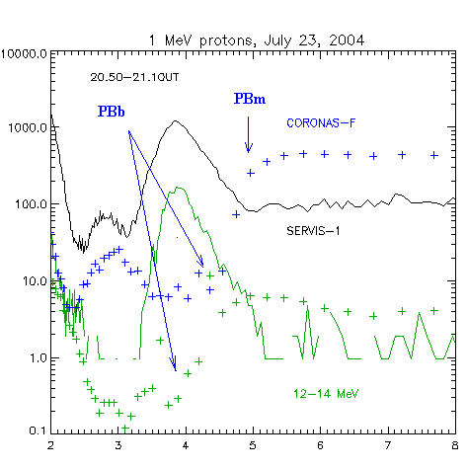
Fig. 2b. Comparison of the radial profiles of solar protons, SERVIS-1 (solid lines) and CORONAS-F (dotted lines). Positions of the penetration boundaries defined at background (PBb) and maximum (PBm) intensity levels are shown by arrows. two energy ranges are shown, ~ 1 MeV and 12-14 MeV.

Figure 3 shows both PBb and PBm dynamics. We use C-F 1-5 MeV proton data, because in other C-F
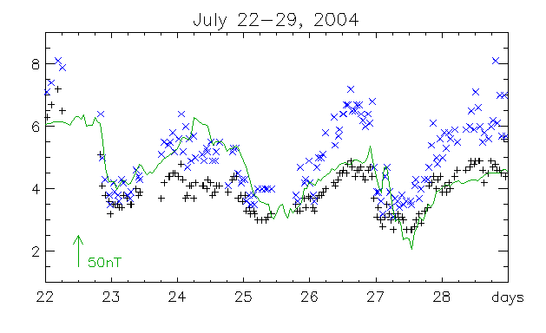
Fig. 3. Dynamics of the 1-5 MeV proton penetration boundary (PBb and PBm) and Dst index (solid line)

channels intensity was not high enough all that period. During last magnetic storm proton precipitation from the newly trapped belt was high and definition of the PB positions was not accurate. From the Fig 3 one can see that PB approached the Earth to L=3 and therefore trapping of SCR to the inner belt was possible.

2.3. Trapping history of 1-15 MeV protons

Two time intervals every day S-1 orbit enters South Atlantic (or Brazilian) magnetic anomaly (BMA).
We chouse 17-19 UT BMA orbits every day from July 22 to 30, 2004 to follow changes of the particle radial profiles. Fig. 4 shows the resulting comparison. First two profiles, July 21 and 22 have a maximum at L=3, such position is typical for the inner belt of 1 MeV protons. The July 22 profile was measured after the SC but no possible results of the SC injection were seen. July 23 and 24 profiles were measured during the recovery phase of the first magnetic storm. We found there additional enhanced maximum at L=3.8. Penetration boundary at the end of the main phase was as close as L=3.5 and therefore this new belt might be the result of solar proton trapping during the retreat of the PB at the recovery phase.
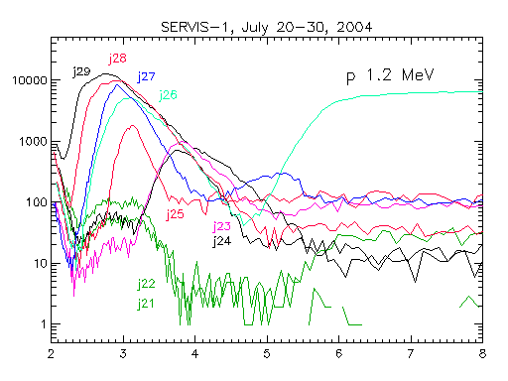
Fig. 4. Latitudinal dependence of the 1 MeV solar proton intensities over BMA, taken one per each day at 20-22 UT from July 21 to 29, 2004, S-1 data.

Next profile transformation was registered on July 25 again during recovery phase. Maximum at L=3.8 disappeared because PB during the main phase of the second magnetic storm approached closer to the Earth and previously trapped particles found themselves at the open drift shells. After PB retreat new maximum arrived located at L=3.
Evening pass of the July 26 was at the end of the recovery phase, maximum position remains at the same place, but intensity increased twofold. Similar intensity increase continued next four days, all profiles measured during recovery phase of the third magnetic storm. Maximum position was shifting gradually earthward, which indicates to the action of the electric (ExB) drift where electric field might be induced by the magnetic field increase during the decay of the ring current. It is possibly also that magnetic field pulsations increase the rate of the inward radiation drift. Radial profiles measured by S-1 12.5 MeV proton channel looks similar to 1 MeV ones.
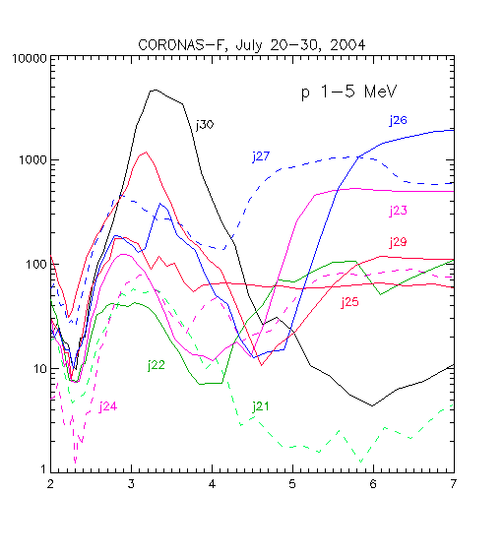
Fig. 5. The same as Fig.4. for C-F measurements.

Radial profiles of 1-5 MeV protons measured by C-F at the 500 km altitude looks rather different (Fig. 5). We do not see trapping protons after the first and the second magnetic storms: loss cone became empty in a short time. After the third storm trapping proton intensity increased significantly and C-F registered trapped particles over BMA, and also precipitating protons in other longitudes.
We will discuss energetic electron dynamics in a separate paper, here will only mention that there is remarkable similarity of proton and relativistic electrons dynamics.
The last magnetic storm has a strongest SC amplitude ( 40 nT in Honolulu) therefore we inspected particle measurements in nearby orbits is search of

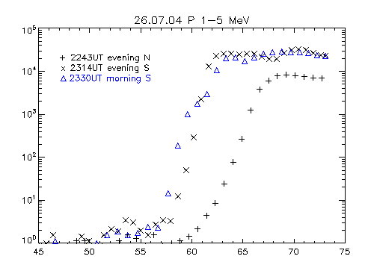
Fig. 6. C-F 1-5 MeV proton radial intensity profiles before and after the SC (26.07 22.49 UT)

possible SC injection effect. Fig 6 presents radial profiles of 1-5 MeV protons measured by C-F 5 minutes before and 25 minutes after the SC. There was large shift of the penetration boundary and measurable increase of the proton intensity which cannot be associated with SC injection. Increase magnitude was the same over all the polar cap and evidently follows the proton increase outside the magnetosphere in the solar wind created by the Fermi acceleration at the front of the CME flux. We also did not find SC injection signatures in other channel of C-F and S-1 as well.

2.4. Time history of a new trapped belts

New created solar proton radiation belts registered by Coronas-F and investigated in previous studies
(Lazutin et al., 2006, 2007) remain observed not for a long time. After two November 2001 magnetic storms particle flux decreased by an order in 15-20 days. After October 29-30, 2003 extreme magnetic storms 1 MeV proton belt exists at the same intensity during 20 days, until the next superstorm and after it disappeared rapidly.
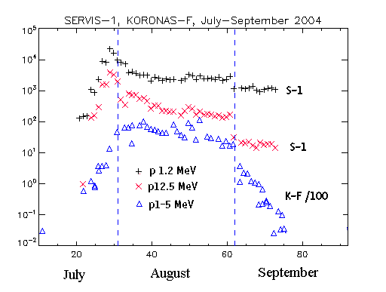
Fig. 7. Temporal behavior of the proton intensity at L=3 after July 22-28 magnetic storms.
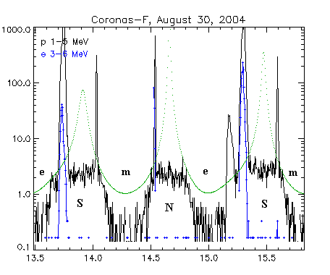
Fig. 8. Several orbits of the C-F with proton and electron measurements, August 30, 2004. By dotted line L-values are shown. Peaks of the precipitation were recorded at L=2.5-4.

In our case during whole August 2004 there were no magnetic storms, and substorm activity was rather low. As a consequence newly trapped particles, both electrons and protons, remain at constant level or decreased much more gradually than after November 2001 storms. Figure 7 shows new radiation belts time history. Trapped 1 MeV proton intensity at S-1 altitude decreased rapidly during several days starting at July 28 until August 3. After that nearly constant intensity level was registered by 1.2 MeV channel and only slow decay by 12.5 MeV channel. At the C-F altitude similar decay rate was registered by 1-5 MeV channel.
Then during whole day of August 30 gradual main phase of the magnetic storm was observed with minimum Dst=-130 nT. Also during this whole day magnetospheric substorm activity was registered in auroral zone. As a result, fast decrease of the particle intensity was observed. The rate of the intensity jump was greater at C-F as compared with S-1 and for higher electron or proton energy.
The reason of the intensity dropouts was in strong precipitation observed during more than 12 hours of August 30, 2004. Fig 8 shows example of the proton and electron precipitation measured by C-F detectors. Similar particle behavior was registered by S-1 detectors.
Again we will note that both slow intensity decrease and July 30 dropout were registered also by energetic electron channels of both satellites, but detailed consideration of electron dynamics will be regarded separately.

3. Summary and conclusion

Joint analysis of the particle measurements on board of two polar satellites with different altitude not only allows to confirm validity of the low energy solar proton trapping mechanism described earlier, but reveals several new features of the solar proton dynamics inside the magnetosphere during magnetic storms.
1. For the first time we have the possibility not only to find the trapping effect, but to record detailed time history of the PB radial motion and associated effects during magnetic storms. Solar protons penetrate directly to low L shells during the main phases of the magnetic storms and during the recovery phase 1-15 MeV protons remain there trapped while more energetic particles were drifting off the magnetosphere.
First solar proton freshly trapped flux was recorded during the first magnetic storm recovery, but in was destroyed when PB went earthward to smaller L during the second storm. Distortion of the magnetosphere during the second storm allows previously trapped protons to escape from this region which transit to the quasitrapping regime.
At the recovery phase of the second magnetic storm new solar proton trapping occurs with maximum at L=3. During the recovery of the last, third magnetic storm intensity of this belt was gradually increasing and the position of the maximum shifts earthward. Therefore three basic processes are taking place during magnetic storms:
- sweeping away of previously trapped protons beside the penetration boundary caused by the losses of the adiabacity because of the magnetosphere distortion during the main phase of the magnetic storm,
- trapping of the solar protons during the fast magnetosphere recovery during magnetic storm recovery phase,
- acceleration of the newly trapped protons not only due to in situ increase of the magnetic field magnitude, but also due to the earthward shift of the magnetic drift orbits. This shift may be caused by induced electric field or/and fast radial diffusion caused by interaction with electromagnetic emissions.
2. We did not find effects of the solar proton injection and acceleration by SC induced mechanism.
3. After magnetic storm, time history of the trapped solar protons have two regimes. In the absence of the magnetospheric disturbances slow intensity decrease was recorded with the decay factor greater for more energetic protons and for lower altitude of the satellite i.e. lower altitude of the mirror point. Particle interaction with atmosphere may possibly explain these relations. It is therefore appropriate to suppose that 90˚ (trapped) particle intensity will remain constant for a long time.
During magnetic disturbances, storms or substorms, fast intensity decay can took place. One obvious reason is wave-particle interaction leading to pitch-angle diffusion into the loss cone.
Second type of the pitch-angle diffusion might be caused by the loss of the adiabacity, namely when magnetic field line radius of the curvature decreased and became comparable with the trapped particle Larmor radius. For more energetic particles this second type diffusion rate is higher which is in accordance with observed relation of the intensity dropouts measured by S-1 and C-F on August 30, 2004.
Solar particle trapping to the inner radiation belt during recovery of the strong magnetic storms therefore might be regarded as a important source of the Earth inner radiation belt.

Acknowledgements

This study was partly supported by the grant № 06-05-64225 of the Russian foundation for Basic Research. One of the authors (LL) is grateful to professor Yu.I. Logachev for a helpfull discussion.

REFERENCES

Blake, J.B., Kolasinski W.A., Fillius R.W., and Mullen E.G. Injection of electrons and protons with energies of tens of MeV into L > 4 on 24 March 1991, Geophys. Res. Lett. 19, 821, 1992.
Bostrem et al. Time history of the inner radiation zone, October 1965 - December 1968, J. Geophys. Res. 75, 1246-1256, 1970.
Hudson, M.K. , Elkington S.R., Lyon J.G. et al. Simulations of proton radiation belt formation during storm sudden commencements, J. Geophys. Res. 102, 14087-14102, 1997.
Kodaira S., Asaeda M., Fujii M., Hareyama M., Hasebe N., Kajiwara N., Sakurai K., Akiyama M., Ichiji K., Hama K. Space and Time Correlations of Particle Fluxes after Giant Flares in Radiation Belts Observed by Two Satellites, USERS and SERVIS-1, Proceedings of 29th International Cosmic Ray Conference, Pune, 101-104, 2005.
Kuznetsov S.N. and Suvorova F.V., Solar wind control of the magnetopause shape and location, in: Rdadiation measurements 26, #1, 413-415,1996.
Lazutin L.L., Kuznetsov S.N. and Podorolsky A.N. Solar proton belts in the inner magnetosphere during magnetic storms. Proceedings of the 2d International Symposium Solar Extreme Events: Fundamental Science and Applied Aspects, Nor-Amberd, Armenia, 26-30 September 2005, Ed. by A. Chilingarian and G. Karapetyan, CRD, Alikhanyan Physics Institute,
Erevan, 63-67, 2006.
Lazutin L. L., Kuznetsov S. N., and Podorolsky A.N., Dynamics of the radiation belt created by solar protons during magnetic storms, Geomag. and Aeronomy 47, №2, 187-197, 2007
Li, X., Roth I., Temerin M., Wygant J.R.,.Hudson M.K, and Blake J.B., Simulations of the prompt energization and transport of radiation belt particles during the March 24, 1991 SSC, Geophys. Res. Lett. 20, 2423, 1993.
Lorentzen, K.R., Mazur J.E., Loper M.E., Fennell J.F., and Blake J.B., Multisatellite observations of MeV ion injections during storms, J. Geophys. Res. 107, 1231, 2002.
Mineev Yu.V., Spirkova E.S., Glukhov G.A., Kratenko Yu.P., Features of solar cosmic ray penetration into the high-latitude regions of the Earth's magnetosphere inferred from Intercosmos-19 data. Proc. of 18-th Intern. Cosmic Ray Conf., Bangalore, India, v.3 p. 262-265, 1983.
Pavlov N.N., Tverskaya L.V., Tverskoy B.A., Chuchkov E.A., Variations of the radiation belt particles during strong magnetic storm of March 24, 1991. Geomagnetism and Aeronomie 33, #6, 41-45, 1993 (R).
Slocum, P.L., Lorentzen K.R., Blake J.B., Fennell J.F., Hudson M.K., Looper M.D., Masson G.M., and Mazur J.E., Observations of ion injections during large solar particle events, AGU Fall Meeting, SH61A-0501, 2002.

